FEDERAL STATE AUTONOMOUS EDUCATIONAL INSTITUTION OF HIGHER EDUCATION
"NATIONAL RESEARCH UNIVERSITY
"HIGHER SCHOOL OF ECONOMICS"
School of Foreign Languages

Chekulaeva Sofya Vitalievna
“A Multimodal Сomparative Analysis of Female Representation in Russian and Spanish Advertising (1930s and 2020s)”

Graduation Qualification Work – BACHELOR'S THESIS
in the field of study 45.03.02 Linguistics
Educational Program "Foreign Languages and Intercultural Communication"

Academic Supervisor
PhD in Philology,
Associate Professor
School of Foreign Languages
E. V. Gabrielova

Moscow, 2025
Table of contents

Introduction....................................................................................................................................4
Theoretical Part.............................................................................................................................7
Section 1: Multimodal analysis of discourse..............................................................................7
1.1. The concept of discourse...............................................................................................7
1.2. The origins of multimodality in linguistics...................................................................8
1.3. Approaches to multimodality in linguistics................................................................10
1.4. Definition of the mode in the theory of multimodality..........................................12
Section 2: Advertising discourse...............................................................................................13
2.1. The concept of the advertising discourse and its linguistic features...........................13
2.2. The role of colour and its significance in advertising discourse.................................14
2.3. Social and motivational advertising as a separate segments of the advertising discourse..........................................................................................................................15
2.4 Multimodality in advertising discourse...............................................................17
Section 3: Female image in the advertising discourse...............................................................19
3.1. Linguistic features of the female image representation in the advertising
discourse.............................................................................................................................19
3.2. Factors affecting the representation of female images in the advertising discourse...20
3.2.1 Cultural aspects....................................................................................................21
3.2.2 Political system....................................................................................................22
3.2.3 Social aspects.............................................................................................23
Key findings from Theoretical Part...................................................................................23
Practical Part................................................................................................................................24
Section 4: Methodology.............................................................................................................24
4.1.Analysis of the Soviet posters of the 1930s.............................................................................28
4.1.1. Soviet agitational posters of the 1930s.....................................................................28
4.1.2. Soviet commercial posters of goods of the 1930s...........................................................34
4.2 Analysis of the Spanish posters of the 1930s..........................................................................41
4.2.1. Spanish agitational posters of the 1930s..........................................................................41
4.2.2. Spanish commercial posters of goods of the 1930s...................................................48
4.3.Analysis of the Russian ads of the 2020s................................................................................55
4.3.1. Russian social and motivational ads of the 2020s.....................................................55
4.3.2. Russian commercial ads of goods of the 2020s...............................................................62
4.4. Analysis of the Spanish ads of the 2020s...............................................................................70
4.4.1. Spanish social and motivational ads of the 2020s...........................................................70
4.4.2. Spanish commercial ads of goods of the 2020s...............................................................76
Key findings from Practical Part................................................................................................85
4.5 Comparative analysis....................................................................................................92
Conclusion....................................................................................................................................94
References.....................................................................................................................................97
Figure A (figures A1-A6)...........................................................................................................104
Figure B (figures B1-B4)...........................................................................................................105
Figure C (figures C1-C5)...........................................................................................................106
Figure D (figures D1-D5)...........................................................................................................107
Figure E (figures E1-E4)...........................................................................................................108
Figure F (figures F1-F6)............................................................................................................109
Figure G (figures G1-G4)..........................................................................................................110
Figure H (figures H1-H6)..........................................................................................................111

Introduction
Advertising is usually considered a marketing strategy for promoting products and services. However, it also plays a crucial and more inclusive role in reflecting social ideals, norms, and values through imagery and language (McDonald et al., 2020). The gender phenomenon, especially the portrayal of female figures, is a key aspect of this reflection in advertisements. Previous research has investigated female portrayals in various media, such as magazines (Bolotova, 2018; Lirola, 2012; Savostkina, 2018), and the language used in female ads (Marco, 1997; Miroshnichenko, 2013). Nevertheless, insignificant attention paid to evolution of the female ideals representation within specific cultures and time periods. This research aims to address this gap by comparatively exploring the ideals constructed through female images in Soviet-era and Spanish advertising from the 1930s, as well as current advertisements (2020s) in Russia and Spain, focusing on agitational posters, social advertising and commercial advertisement of goods. By focusing on visual and stylistic devices, this paper reveals how advertising reflects social and cultural perspectives on women's identity across two different historical periods and cultures.
This study aims to provide answers to the following research questions:
- How do linguistic and visual representation of women in the Soviet and Spanish advertising posters of the 1930s contrast with those in contemporary Russian and Spanish advertisements of the 2020s ?
- What specific visual and stylistic strategies are employed to construct feminine ideals in each context?
- How do the socio-political and cultural contexts of these two periods affect these portrayals?
To answer the research question, the following objectives are established:
- Define such concepts as advertising discourse, multimodal approach, stylistic analysis, female representation, and influencing factors.
- Analyze linguistic and visual strategies and their interaction in the advertising discourses of agitational posters, social and motivational ads, and commercial advertising of goods.
- Conduct a comparative analysis of findings to assess the female representation evolution and the influence of social, political and cultural factors on the advertisements.
This research makes an attempt to understand how advertising reflects political, social, and cultural definitions of feminine ideals through verbal and non-verbal communication, creating a foundation for further research in the field of media, linguistic and cultural studies to create a more inclusive and authentic imagery of women.
This study employs a variety of analytical methods. Firstly, targeted data collection is used to gather relevant material and make conclusions based on observed information. Secondly, the collected advertisements are analyzed using Kress and van Leeuwen's (2006) framework for multimodal analysis that aims to provide a detailed understanding of how meaning is constructed through the interplay of visual and textual elements in each advertisement. Thirdly, to further explore the expressive function of the advertisements, a stylistic analysis is conducted based on Shakhovskiy's (2013) approach. This analysis focuses on identifying various expressive means on phonetic, lexical, morphological, syntactical, phraseological, and graphical levels that are supposed to reinforce persuasive intent of advertisments and evoke emotional response. To combine both approaches of analysis, a special form is created. Finally, following the multimodal and stylistic analyses, a comparative analysis is conducted to identify similarities and differences in the representation of female figures across the two time periods and locations.
This study is relevant because advertising plays a significant role in shaping and reflecting societal perceptions of female identity, and understanding of how women are represented in advertising across different cultural and historical contexts contributes to exploration of evolving social norms and values within those societies. Influence of advertising in contemporary society and understanding the role of advertising is vital for promoting more inclusive representations of women in media.
The theoretical significance lies in its contribution to the existing knowledge of female representation, multimodal approach and stylistic analysis within advertising discourse, broadening the frameworks of discourse analysis and semiotics in the field of linguistics. Exploring the verbal and non-verbal cues used in female representation across distinct time periods and cultures provides an opportunity to understand how social, cultural and political changes may influence the choice of specific visal strategis or stylistic devices to represent the female ideals.
As for the practical significance, this paper may inform advertisers, content makers and linguistis about how female gender is constructed and perceived, promoting more responsible, effective, and inclusive advertising strategies with the most appropriate language and imagery use. The comparative analysis clarifies how social, political and cultural changes influence media female representations, providing context for future research for market researchers, sociologists, historians, and cultural scientists.
Approbation of the work:
The results of the study were presented at the student conference the X scientific interuniversity online conference of young scientists "Space of scientific interests: foreign languages ​​and intercultural communication - modern development vectors and prospects" (18.04.2025). On the basis of the study the article was also written and is reviewed in the collection of the conference "Space of scientific interests".

Theoretical Part
Section 1. Multimodal analysis of discourse
1.1. The concept of discourse
The concept of discourse is a crucial concept across linguistics, philosophy, and sociology, where researchers investigate the interconnected relationships between language, identity, and social interactions. The term "discourse" derives from the French word "discours," which signifies a "process of understanding, reasoning, and thought", and originates from the Latin word "discursus", meaning "conversation". This etymology highlights discourse as a unit of expression that includes both oral and written forms (Khurmatullin, 2009). So, discourse is understood as a connected word integrated within sentences and, then, speech acts.
Nevertheless, it is essential to distinguish the concepts of text and discourse, as both of them represent a coherent text. As time has passed, the understanding of discourse has evolved, and started to exist within a more complex social context. By including the category situation in this pair, it was proposed to interpret discourse as “text and situation”, while text, accordingly, was defined as “discourse without situation” (Kurbanova & Shonazarova, 2023). Foucault (1969) conceptualized discourse as "a set of statements belonging to a single system of formation", indicating that discourse is characterized by specific discursive practices. This perspective suggests that discourse should be analyzed both from the perspective of linguistic phenomena and from a dynamic social aspect that shapes and is shaped by social norms and history. Artyunova (1990) further supports this notion by defining discourse as a coherent and logical text combined with extralinguistic factors, such as pragmatic, socio-cultural, psychological, and others. This definition emphasizes that speech is not a simple tool for communication but a purposeful social action that plays a crucial role in human interaction and the mechanisms of consciousness. This understanding positions language within a broader social framework, asserting that it is contextually bound and deeply connected with social interactions. Thus, three main aspects of discourse can be identified: the language use, the transmission of specific ideas, and interaction in comminication situations (Van Dijk, 1997). These features emphasize the involvement of linguistics, psychology and and other social sciences in the study of discourse. Building upon this foundation, Karasik (2002) advanced discourse theory by creating an analytical model with four discourse categories defined by textual features: coherence, cohesion, and various types of intertextuality: constitutive, genre-specific, semantic-pragmatic, and formal-structural that all contribute to the feature of the text,
highlighting its style, meaning and organization.
So, by integrating these perspectives and frameworks, the complexity of discourse can be understood as a rich field of study that interconnects language, social interaction, and cultural context that serves as a foundation for analysis of multimodal and advertising discourse.
1.2. The origins of multimodality in linguistics
Contemporary linguistics increasingly recognizes that language is more than just spoken or written words, integrating a broader range of factors into its analyses. A significant amount of research acknowledges the vital role of other communicative resources like visuals, sounds, gestures, and spatial arrangements in the construction of a specific meaning (Jewitt, 2009; Kress & van Leeuwen, 2001; O'Halloran, 2008). This shift has given rise to the study of multimodality, which explores how these various features of communication (modes) interact and contribute to overall discourse.
To start with, еhe term "multimodality" provides a way for examining communicative situations within a wider context, acknowledging the combined influence of diverse modes like spoken and written language, visuals, spatial arrangements, and non-verbal communication. (Bateman, 2016). Previously, Halliday (1978) introduced a systemic functional linguistics that had been a crucial foundation in understanding language as a social semiotic resource. His focus on the functional aspects of language created a base for identification of visual and linguistic features in multimodal communication. Based on it, the concept of “metafunctions” was introduced that encompasses ideational, interpersonal, and textual functions of both language and imagery: representational meanings can be conveyed through concepts or narratives, interpersonal function is reflected in engaging viewers through emotional or relational cues, and textual one organize elements for clarity and proper understanding (de Silva Joyce & Gaudin, 2007). This classification may inеroduce a foundation for a more detailed linguistic and visual elements analyses and create a deep realization of a particular meaning of the message.
Influential contributions stemming from this perspective include Kress and van Leeuwen’s (2001, 2021) works who realized Halliday’s ideas of multimodality in a more detailed and representative way. They developed a comprehensive framework for analyzing visual images using these functional concepts, defining the resources through which visual texts can represent ideas about the world, their authors and addressees, and shape cohesion about what is represented. Recognizing that meaning-making extends beyond language to encompass a variety of semiotic resources, they developed a complex framework for analyzing visual images and other non-linguistic modes of communication. Such aspects as representational processes, interactive processes, compositional meaning, modality, and color are introduced (Kress & van Leeuwen, 2021). All of these features contribute to a comprehensive understanding of how different semiotic resources interact within a text, also emphasizing denotation, connotation, and the relationship between images and text. Thus, their approach goes beyond the identification of individual elements of multimodality but creates a foundation for their interconnectedness.
What is more, a thorough multimodal analysis requires considering both the interplay of visuals and language and conducting a distinct stylistic analysis in order to achieve a complete understanding of the identified materials. According to Shakhovskiy (2013), stylistic analysis employs a sophisticated approach for examining linguistic features across multiple levels: phonetic, morphological, lexical, phraseological, syntactical, and graphical. This exploration of linguistic features enriches understanding of how language operates within multimodal contexts of advertising discourse to create meaning and convey specific messages. In particular, Shakhovskiy's framework helps identify the persuasive strategies and emotional appeals employed in a text, as well as the values, beliefs, and assumptions that are embedded within it.
Collectively, these investigations underscore the complex framework of multimodal analysis and its capacity to reveal how communication functions across diverse semiotic resources. Uniting studies from both Kress and van Leeuwen with Shakhovskiy's stylistic analysis allows for a more profound understanding of meaning creation in a variety of communicative contexts. These scholars help establish a foundation that develops verbal understanding of language, emphasizing the necessity of including visual, spatial, and other non-verbal resources in the analysis of communication, which has led to the emergence of multimodal discourse analysis as a distinct field.
1.3. Approaches to multimodality in linguistics
The field of multimodality has grown rapidly, resulting in a diversity of approaches, each with its own emphasis and methodological preferences. There are several prominent approaches.
Firstly, based on the work of Halliday (1978), the social semiotic approach emphasizes the social and cultural context of communication. It views language and visuals not only as channels for transmitting particular information but as socially and culturally constructed resources for creating meaning. Social semiotics highlights how choices of specific means are related to social power, ideology, and cultural values. The metafunctional framework derived from this approach is essential for analyzing how different units contribute to ideational, interpersonal, and textual meanings. This approach is used widely in the study of textbooks, media, and other cultural traits, emphasizing the social impact and ideological underpinnings of multimodal texts.
Secondly, interactional multimodality influenced by Goffman (1981) on face-to-face interaction, centers on the analysis of multimodal meaning-making in conversational contexts. It focuses on how participants use gestures, facial expressions, body posture, gaze, and other bodily resources in conjunction with speech to coordinate their interaction and convey intended meaning. This approach is very closely related to conversation analysis and ethnography (Mondada, 2016). For example, in her work on interactional linguistics and multimodality, she has explored how embodiment and materiality are crucial for understanding the interactive organization of social actions. This approach often uses video recordings and close analysis of interactional data.
Thirdly, the multimodal cognitive linguistics approach bridges cognitive linguistics with multimodal analysis (Forceville & Urios-Aparisi, 2009). It uses knowledge from cognitive psychology to examine how individuals process and perceive multimodal information. This approach investigates mental representations, conceptualizations, and cognitive processes involved in understanding multimodal messages. To explore this, they developed a concept that extends the traditional understanding of stylistic techniques such as metaphor beyond language and allows for other ways to explore cognitive operations that enhance understanding of multimodal expression with the usage of visuals.
Next, critical multimodal analysis combines multimodal analysis with critical theory and seeks to examine the power relations, social inequalities, and ideological biases present in multimodal texts and interactions. Following Fairclough’s (1995) analysis of language and power, it aims to identify the ways in which linguistic and visual components dominate among particular groups and marginalize others, analyze the complex relationships between discourse and society, the reflection of the social power structures (the hierarchical organization of power and influence in a society) in language, and consider the problem of social inequality expressed in discourse (Matitsina, 2019). What is more, critical multimodal analysis often involves the study of advertising, political discourse, and other contexts where power dynamics are particularly remarkable. All approaches of CDA operate with such categories as tense, metaphor, attribute, and argumentative structure of the communicative act, but the theoretical basis and methodology of different schools of CDA have some differences.

The multidisciplinary field of multimodality, reflected in these varied approaches, connects disciplines like linguistics, semiotics, sociology, psychology, and critical theory. By examining the interplay of different modes, each approach offers a unique perspective on how meaning is created and how our understanding of the world is shaped.
1.4. Definition of the mode in the theory of multimodality
The concept of “mode” is central figure of the theory of multimodality, but its precise definition can be quite debatable and can have varying interpretations. While there is no single universally accepted definition, several authors provide their interpretations of the concept of “mode”.
Kress (2010, p.79) defines a mode as a "socially shaped semiotic resource for realisation of discourse or making meaning". This definition emphasizes that modes are not just physical channels or media for transmitting information, instead, they are understood as cultural and social resources that are actively shaped by human intention and use. He uses examples like writing, speech, and images, and argues that each mode has its own possibilities and limitations, that determine how meanings can be made with them. This definition emphasizes the active and constructive role of modes in meaning-making. Van Leeuwen (2005) also understands a mode as a socially and culturally shaped resource for making meaning and emphasizes that it has a distinct material dimension (its “medium”) and a distinct way of structuring meaning (its “form”). He suggests a mode can be understood on three levels: its material aspect, its structured form, and its social use. Furthermore, modes may have different levels of "specificity" in relation to what they represent; for instance, words may be more specific in their meaning compared to images, while images may be more evocative. His distinction between material, form, and social use adds analytical depth to understanding the concept of “mode”. Jewitt (2009) and O'Halloran (2008) expands on this definition by categorizing modes into two main types: representational modes, which convey content or information, and interactive modes, which engage the audience in the communication process. This distinction is crucial for understanding how different modes function within a text and how they relate to one another. Thus, these definitions emphasize that a mode is not a simple medium or channel of communication, it is a culturally and socially shaped system of resources that actively contributes to the construction of meaning.
In conclusion, the study of multimodal discourse is rooted in a rich theoretical foundation that emphasizes the mutual performance of various modes of communication. By exploring the origins, approaches, and definitions of multimodality, it may provide a base for understanding how meaning is constructed in a complex multimodal aspect.

Section 2: Advertising discourse

2.1. The concept of advertising discourse and its linguistic features
Jorgensen and Phillips (2002) often understand discourse as “the general idea that language is structured according to patterns that determine the utterances of people in various spheres of social life. That is why, various types of discourses started to appear, like “scientific discourse”, “political discourse”, and “advertising discourse” (Baker & Ellece, 2011).
Advertising discourse can be defined as a specialized communicative practice that aims to promote products, services, or ideas through various linguistic and non-linguistic means, so it can be also connected with the multimodality, as it rarely relies only on text, as, for instance, visual imagery can evoke emotions, audio can set a mood, and text conveys specific information, creating a memorable effect. In addition, advertising discourse often utilizes a high degree of intertextuality, drawing on cultural references and connotations of words and images to evoke desired behaviour (Barthes, 1977). Olyanich (2011) identifies advertising discourse as a unique socio-cultural phenomenon that influences various spheres of human activity through its potential to shape public consciousness, influence behavior, and share information about goods and services. Further, advertisements often use evaluative and imperative linguistic features to manipulate audience perception and behavior (Leech, 1966). For instance, epithets in the form of the superlative adjectives, hyperbole, and direct demands.
Further contribution to the field of linguistic features of advertising discourse is made by Emodi (2011), who investigates the semantic choices and persuasive strategies used in advertising language, distinguishing between denotative and connotative meanings. It also incorporates a variety of linguistic techniques, including metaphor, wordplay, deliberate misspelling, and repetition. The research explores how advertisers manipulate these features to evoke emotions, create strong visual associations, and improve message recall through repetition and ambiguity. Additionally, Vasiloaia (2014) identifies phonetic and semantic features such as rhythm, rhyme, alliteration, assonance, graphic elements, and transliteration, which contribute to the overall persuasive effect. Another significant aspect of advertising discourse is its use of hyperbole and exaggeration. As noted by O’Shaughnessy (2003), advertisers often employ persuasive strategies, and extravagant claims to capture attention and create a sense of urgency. This linguistic feature is frequently accompanied by visual elements that reinforce the message, as seen in advertisements that showcase products in idealized settings. All these studies contribute to the complex and detailed exploration of advertising discourse and its unique features.
1.2.2 The role of color and its significance in advertising discourse
Color plays a critical role in advertising, acting as a powerful tool to evoke emotions, establish brand identity, and influence consumer behavior (Ghaderi et al., 2015). The psychology of color is deeply rooted in cultural associations and personal experiences, meaning effective color usage requires a nuanced understanding of the target audience. Specific colors often carry specific connotations. For instance, red is an intense color and has a vibrant and powerful impact on emotions, as it is used to indicate celebration, purity, passion, strength, energy, excitement, power, danger, blood, war, revolution and communalism. Additionally, this color is popularly used by product designers and advertisers to highlight objects of importance and to encourage viewers to take actions. Next, orange, as well as red, has very high visibility, so it is used to catch attention and highlight the most important elements of the design, representing fun, optimism, support and sociability. Blue is considered to reflect tranquility, trust, confidence, liberty, wisdom, wealth, and truthfulness, whereas yellow signifies sunlight, joy, earth, optimism, intelligence, hope, feminity, and friendship. As for green, it signifies growth, nature, youth, health, and stability, and brown stands for an earthy and environmental quality and is generally coupled with green. It is used to represent calmness, nature, and tradition. Purple color is considered to be the color of humility,ceremony, mystery, sensuality, pride, while pink is used to symbolize appreciation, admiration, sympathy, health, feminity, love, joy, and innocence. Furthermore, black and white in tandem demonstrate cleanliness, fearfulness, seriousness, modernity, elegance, and professionalism, while gray is used to portray elegance, respect, wisdom, old-age, balance, and neutrality (Cerrato, 2012; Singh & Srivastava, 2011). Overall, the strategic application of color is essential for creating persuasive advertising campaigns that resonate with consumers and translate the main ideas with the proper connotations.
1.2.3. Social and motivational advertising as a separate segment of the advertising discourse
It is interesting to know that the term “social advertising” is used only in Russian advertising discourse, whereas in other countries the term “public advertising” is used for this phenomenon (Tomilin, 2010). The Federal Law No. 38-FZ of March 13, 2006 "On Advertising" provides the definition of social advertising as representation of public and state interests that aims to achieving charitable goals. The following interpretation can be found in scientific literature that defines social advertising as a special type of non-commercial information aimed to achieve certain social goals by the state, executive authorities or non-commercial organizations (Gribok, 2008; Vainer & Gladkikh, 2012). In any case, social advertising should not be considered as a separately existing phenomenon, but within the framework of the general system of public relations.
According to Kinnick et al. (1996), social advertising employs similar linguistic strategies as commercial advertising but often emphasizes ethical appeals and social responsibility. As for main strategies utilized in social advertising, it is vital to highlight the following features: simple sentences, simple words and phrases, and persuasiveness. It can be represented in the stylistic devices used in such advertising: imperative verbs, personal pronoun “you”, exclamatory sentences, explicit complex imagery that sometimes need an analysis for understanding, and emotive language with the usage of positive or negative connotations of words that evoke strong emotions and contribute to the meaning of recommendation to do something (Tatisheva, 2019). Cheremisina (2016) also examines the linguistic features of social advertising, focusing on various parts of speech that influence audience perception. She points out that verbs in the imperative mood are crucial for calls to action, while nouns and adjectives evoke emotional responses, also the use of statistics and numbers enhances the persuasive impact of advertising messages.
Thus, the main goal of the social advertising discourse is to influence the worldview of the social addressee, possibly changing his opinions, beliefs, and social attitudes (Zvada & Kuznetsova, 2019). The effectiveness of social advertising is often evaluated through its ability to resonate with the target audience. This approach not only raises awareness but also fosters a sense of community and collective responsibility.
Another popular type of advertising is motivational. It is a form of advertising that aims to inspire and motivate individuals. They often use inspiring messages, images, and stories to encourage people to take action, pursue their goals, or adopt positive attitudes (Support, 2024). While traditional advertising focuses on features and benefits, motivational advertising connects with consumers on a deeper psychological level, leveraging theories from behavioral science and neuroscience. For instance, brands like Nike does not just sell products, but looks for innovative ways to connect with its audience through creativity like the Nike+ platform. It’s an app that invites all Nike members to engage with one another, share their stories and promote active lifestyle (Garces, 2024). Additionally, emotions play an essential role in motivational advertising. Research by Berger and Milkman (2012) found that content evoking strong emotions such as inspiration, excitement, or even fear is more likely to be shared and remembered. For example, public campaigns on health risks because of negative addictions may use fear appeals to motivate behavioral change.
As for the main features of the motivational advertising, it is quite similar with the social advertising, where a call to action, imperatives, personal pronouns “I” and “you”, epithets, metaphors, hyperbole, comparisons, personifications, repetitions, rhyming slogans, and personification (Ivanova & Ponomareva, 2021). All of these strategies provide an opportunity to express effectively the implied meanings and evoke emotional response.
In summary, social advertising represents a distinct segment of advertising discourse that prioritizes social change over commercial profit. Its linguistic features and multimodal elements work together to create persuasive messages that aim to inspire action and raise awareness of social issues, whereas motivational advertising is an effective tool that can foster deep connections with the viewers and motivate them to do or not to do specific actions,maintaining authenticity and trust.

2.3. Multimodality in advertising discourse
As it was stated earlier, multimodality refers to the use of multiple modes of communication, including visual, auditory, and textual elements, to convey meaning. In the context of advertising discourse, multimodality plays a crucial role in enhancing the persuasive impact of advertisements. According to Kress and van Leeuwen (2006), advertisements often combine images, text, and colors to create a cohesive message that appeals to various senses. This multimodal approach allows advertisers to create rich and engaging narratives that resonate with consumers. For instance, a print advertisement for a luxury product for women may feature high-quality images, elegant typography, and a sophisticated color palette to evoke feelings of prestige and desirability. Furthermore, social advertising often leverages multimodal elements to enhance its impact. As for social advertising, according to Gunter and Furnham (1992), the combination of visual and verbal communication in social advertising can create a more compelling message. For example, campaigns promoting gender inequalities may use striking visuals of harassment alongside powerful slogans to evoke a sense of urgency and responsibility.
In this context, the popularity of posters, that exemplify the multimodal nature of advertising discourse, has experienced significant surges during crucial historical and social events. The interplay between image and text in posters can create a powerful emotional response, making them an effective medium for both commercial and social advertising. For example, one such period was during the Russian Civil War (1917–1923), a time marked by the emergence of diverse social ideologies, movements, and transformations. Posters played a crucial role in this era as tools for agitation, mobilization, and unity among the people. They served as vital instruments for navigating challenging times (Symonovich, 2018). It was that period when the Soviet posters presented a unique context for analyzing women's depiction, since they were one of the main figures of promotional ideas. These portrayals emphasized women's roles in nation-building efforts by depicting them as multifaceted figures: workers, mothers, and public activists (Bolotova, 2018; Mispoulet, 2006; Savostkina, 2018). These studies highlight popular female "missions" represented on these posters and explore why such representations were prevalent and provide background for understanding the choice of visuals and language used in female representation of that era.
As for the advertising of goods, the use of multimodal elements can enhance brand recognition and build trust. According to Bakhurst (2007), advertisements that employ consistent visual and textual elements across various media can strengthen brand identity and consumer loyalty. This is evident in campaigns that use specific colors, fonts, and logos to create a cohesive brand image across print, digital, and other platforms, as the rise of digital media has further expanded the possibilities for multimodal advertising discourse. With the advent of social media and online platforms, advertisers can now incorporate interactive elements, such as videos, animations, and user-generated content, into their campaigns. As noted by McQuail (2010), this interactivity allows for greater audience engagement and participation, leading to more effective persuasive communication.
In conclusion, multimodality is a fundamental aspect of advertising discourse, allowing advertisers to create rich and engaging messages that resonate with consumers. The combination of visual and textual elements, particularly in posters and digital media, enhances the persuasive impact of advertisements and contributes to brand recognition and recall.
Section 3: Female image in the advertising discourse
3.1. Linguistic features of the female image representation in advertising discourse
The representation of female images in advertising discourse has evolved significantly over time, reflecting broader social changes and cultural shifts. The study of female representation in advertising is crucial for understanding how female representation and ideals are constructed, communicated, and transformed through visual and linguistic means. Also, van Leeuwen (1996, p. 43) argues that “representations can reallocate roles; rearrange the social relations between the participants”, depending on the type of information or ideology being conveyed. Research indicates that language extends beyond simple communication, because it is also important in constructing social realities (Foucault, 1969). In the realm of advertising, for example, domestic roles attributed to women are often perceived as innate and general, yet they signify the subordination of women and the superiority of men, who are associated with positions of power in society. However, as time passed, women roles in the society have changed.
Linguistically, specific lexical choices, syntactic structures, and phonetic elements can profoundly influence how women are depicted in advertisements. For instance, alliteration is frequently employed at the phonetic level, and at the lexical level there is the vocabulary that resonates with feminine stereotypes, appealing to themes of family, stability, vulnerability, wisdom, and beauty, often through metaphor and comparison (Monakhova et al., 2023). Also, advertisements often utilize euphemisms and hyperbolic language to enhance the desirability of female figures, thereby reinforcing traditional gender stereotypes (Goffman, 1979). This categorization is reflected visually through elements such as color schemes, the primary figure's gestures and facial expressions, and connotations, as well as verbally through the use of pronouns, persuasive language, disjunctive syntax, vocabulary, and both positive and negative adjectives. By utilizing these features, advertising discourse often categorizes women into archetypes of the ideal of beauty, the portrayal of women as passive objects, the ideal of domesticity, and the stereotype of the liberated woman (Luzón Marco, 1997). Nevertheless, other female roles of the past decades can be pointed out: women as a working force, women as a mother, women as the houskeeper, women as a public activist (Savostkina, 2018). So, the linguistic framing of female images in advertising can reflect existing cultural norms and expectations regarding femininity.
3.2. Factors affecting the representation of female images in advertising discourse
The representation of female images in advertising is influenced by a variety of factors, including cultural norms, political systems, and social dynamics (Rogatin, 2023). Each of these factors contributes to shaping the narrative surrounding femininity and influences how women are depicted in advertisements. Firstly, various cultures have their unique traditions that influence advertising styles and content. For instance, Spanish advertising tends to be more emotionally and visually engaging and memorable, while Russian advertisements often focus on rational persuasion and more patriotic themes (Agrba, 2019). These cultural differences may lead to varied portrayals of women reflected in advertising within different countries and time periods. Secondly, the political system also affects the representation of women in advertising by influencing regulatory environments and societal norms endorsed by the government. For example, during the Soviet era, advertising was heavily controlled to align with state policies rather than individual’s needs. Thirdly, social factors are also vital, as society evolves, and women are increasingly portrayed in more diverse and powerful roles in advertising (Kordrostami & Laczniak, 2022). Thus, these factors shape the diverse ways female images are represented across different contexts within the advertising discourse that also can influence the usage of specific visuals and language features.
All these stereotypes and biases appear because of the tendencies in media, various political, social and cultural contexts that influence verbal and non-verbal features in the advertising woman representation. Bulycheva (2008) states that in the pre-revolutionary period, advertising of Russian culture was saturated with national features, used plots from folk tales and traditional symbols, which contributed to its perception. During the Soviet period, advertising became imperative, reflecting government policy and ignoring the real needs of consumers. With the transition to a market economy, advertising began to adapt, providing messages that were more familiar and understandable to the audience.
3.2.1 Cultural aspects
Cultural context plays a significant role in shaping the ideals of femininity represented in advertising. Different cultures possess distinct values, beliefs, and practices that inform their views on gender roles. For instance, research by Barthes (1977) highlights how cultural symbols embedded in advertisements can shape societal perceptions. In the Soviet Union during the 1930s, female representation in advertising often aligned with socialist ideals, portraying women as strong, independent workers contributing to the collective (Mespoulet, 2006). Conversely, Spanish advertisements from the same period reflected more traditional notions of femininity, emphasizing maternity in the combination with active political performance.
For instance, in the pre-revolutionary period, advertising of Russian culture was characterized by national features, used plots from folk tales and traditional symbols, which contributed to its perception. During the Soviet period, advertising became imperative, reflecting government policy and ignoring the real needs of society. With the transition to a market economy, advertising began to adapt, sharing ideas that were more familiar and understandable to the audience (Bulycheva, 2008). The Spanish philosophical tradition can be highlighted as improvisational and intuitive, while Russian philosophy emphasizes conciliarity and inner unity, rooted in Orthodoxy. Both traditions strive to synthesize diverse ideas, but the Spanish tradition is more eclectic, whereas Russian philosophy focuses on historical context (Yakovleva, 2003). Providing more differences in comparison between advertising in Spain and Russia, it is defined that Spanish advertising as vivid and emotional, utilizing expressive visual and verbal means to foster a trusting dialogue with the audience. Agrba (2019) states that the style of Russian advertising tends to be more monologue-based and imperative, focusing on rational persuasion and patriotism, which can create a distance between advertisers and audiences. Spanish advertising, with its emphasis on aesthetic elements and information compression, often addresses specific individuals, while Russian advertising tends to appeal to a broader audience, including those who may not be able to solve the presented problems.
3.2.2. Political system
The political landscape significantly impacts the portrayal of women in advertising discourse. Political ideologies dictate the values that are promoted through media channels, including advertisements. The 1930s was a period of major transformation in both countries: in the Soviet Union, it marked a time of rapid industrialization, agricultural collectivization, and the shift toward an authoritarian political regime. Following the Civil War in 1922, widespread political repression also took place (Korovin, 2008). As a result, Soviet posters played a significant role in reshaping female identity, portraying women as essential contributors to the socialist state and promoting their participation in traditionally male-dominated industries and political spheres. That is why advertising was utilized as a tool for propaganda to promote state-sanctioned ideals of femininity (Zaslavskaya, 1997). In contrast, the Spanish poster reinforced existing female roles focues on family, aiming to inspire political actions within familiar values but with the appearing themes of political agitation, although the period of 1930s in Spain was also difficult because of the pre-military time of Spanish Civil War (1936-1939) (Novikov, 2007). Lately, the post-Franco era marked a shift towards more progressive representations of women in advertising, reflecting broader societal changes towards gender equality.
3.2.3. Social aspects
Social factors such as economic conditions, education levels, and technological advancements also contribute to shaping female representation in advertising discourse. The rise of consumer culture in both Russia and Spain has led to an increased focus on individualism and personal identity in advertisements (Baudrillard, 1998). This shift has allowed for more diverse portrayals of women that go beyond traditional stereotypes. Moreover, the impact of social media has transformed how women are represented in advertising. As brands seek to connect with younger audiences, they increasingly utilize influencers and user-generated content that challenge conventional beauty standards and promote authenticity (Marwick, 2015). Furthermore, the activity of feminism ideologies among cultures also contributes to more explicit representation of women. This evolution reflects a broader societal shift towards inclusivity and empowerment in the representation of women.
Key findings from Chapter 1
In the first chapter of this study such concepts as discourse, advertising discourse and its linguistic features, multimodality and modes, linguistic features of the representation of the female images, as well as the influence of culture, politics and the social sphere on the advertising language were explored.
The concept of discourse has its complex and sophisticated origins, as it consists of not only linguistic elements but also social, cultural, and psychological dimensions of communication. So, this highlights that advertising discourse, as a specific type of general discourse, shares the same dimentions of communicaion, aiming to promote commercial and non-commercial products influencing the public opinion. Therefore, the use of various linguistic and extralinguistic techniques helps create persuasive and emotionally impactful messages. Common strategies include the frequent use of metaphors, wordplay, spelling violations, adjectives, repetitions, phonetic and semantic manipulations, as well as rhythm and alliteration.
Another essential concept discussed is multimodality, which encompasses various approaches that analyze how different modes, such as language, visuals, and, gestures, interact to create meaning within social and cultural frameworks. Key methodologies include the social semiotic approach, which focuses on the societal impact of communication choices; interactional multimodality, which explores how multimodal meaning-making is constructed during social interactions; and critical multimodal analysis, which investigates power relations and social inequalities in multimodal texts. Together, these diverse perspectives demonstrate the complex relationship between language, culture, and cognition, underscoring the multidisciplinary nature of the field. This variety of approaches enhances understanding of communication processes and significance of considering social, cultural, and cognitive factors when analyzing multimodal texts and interactions.
Finally, the representation of female images in advertising is shaped by cultural norms, political systems, and social dynamics, which collectively influence the way femininity is portrayed. Cultural differences, such as those between Spain and Russia, lead to varied depictions of women, with Spanish ads emphasizing emotional engagement and Russian ads often focusing on rational persuasion. Political systems play a crucial role as well, with advertising serving as a tool for propaganda in authoritarian regimes, while also reflecting societal shifts towards gender equality in more progressive contexts. Social factors, including the rise of consumer culture and the influence of social media, have contributed to more diverse and empowering representations of women in advertising discourse.
In conclusion, the theoretical study confirms the importance of a multimodal approach and stylistic analysis in the studying of advertising discourse and female representation, emphasizing the relevance of the interaction of various modes and language for the creation of vibrant advertising messages.
Practical Part
Section 4: Methodology
The methodology of this study is complex, aiming to analyze the visual and linguistic representation of female figures in advertising materials across different historical periods and geographic locations. It is based on a collection, classification, and analysis of visual and textual data to understand how meaning is constructed and conveyed through various modes of communication. It consists of 40 samples of the advertising materials, including agitational posters, commercial advertisements of goods, as well as non-commercial social and motivational advertising of the 1930s and 2020s in the Soviet Union, Russia, and Spain. Data was sourced manually, from open online sources such as Pinterest and Google, with the usage of targeted keywords as “women”, “poster”, “Soviet Union”, “Russia” “Spain”, “war”, “work”, “beauty”, “products”, “2020s”, and “1930s”. These materials were divided into eight distinct groups with 4-6 examples for each group based on the following criteria: time period, location, presence of female imagery, type of advertising.
The avertisements were classified according to the following aspects: geographical location, aim and time period. A list of the following groups was formed:
- Group 1: Soviet agitational posters of the 1930s;
- Group 2: Soviet commercial posters of goods of the 1930s;
- Group 3: Spanish agitational posters of the 1930s;
- Group 4: Spanish commercial posters of goods of the 1930s.
- Group 5: Russian social and motivational ads of the 2020s;
- Group 6: Russian commercial ads of goods of the 2020s;
- Group 7: Spanish social and motivational ads of the 2020s;
- Group 8: Spanish commercial ads of goods of the 2020s.
The data analysis is conducted using stylistic (Shakhovskiy, 2013) and multimodal analyses (Kress & van Leeuwen, 2021) that examines how meaning is constructed through the interconnection of various modes.
Based on this research the table for data analysis is created for a more complete analysis of advertising and poster materials of every analyzed group. These methods explore how verbal elements are combined with multimodal ones to represent a distinct female image within different periods and contexts. By integrating these approaches, this study aims to provide a comprehensive understanding of how meaning is constructed through both linguistic style and visual communication strategies. The analysis was conducted against the criteria elaborated from the studies by Kress & Van Leeuwen (2021) and Shakhovskyi (2013) and given in Table 1.
Table 1: advertising elements based on Kress & Van Leeuwen (2021), Shakhovskyi (2013)
Category | Identified Examples
Visual elements based on Kress & Van Leeuwen (2021)
Representational processes: type of processes depicted (narrative, conceptual), use of actors, goals, and circumstances, how are actions and participants represented
Interactive processes: how the images engage with the viewer (direct address, implied viewers), role of gaze, demand or offer images
Compositional meaning: placement of elements, use of information value (left/right, top/bottom), balance, framing and its effect on message importance, salience of depicted characters/objects, how they construct the message
Modality: how realistic, credible or authentic the visual image is, color saturation, sharpness of lines, depth of field, and their effects on meaning creation
Color: dominant colors, use of color symbolism, role of color in the construction of meaning and the relation to the visual narrative
Expressive means & Stylistic devices based on Shakhovskyi (2013)
Phonetic level: euphony, onomatopoeia, alliteration, rhyme, rhythm
Morphological level: transposition of parts of speech
Lexical level: metaphor, metonymy, pun, epithet, hyperbole, euphemism, antonomasia, oxymoron, zeugma
Phraseological level: allusion, quotation
Syntactical level: inversion, parallel constructions, chiasmus, repetition, antithesis, litotes, break-in-narrative, question-in-the-narrative, rhetorical speech
Graphical level: punctuation marks, lack of punctuation marks

Finally, a comparative analysis encompassing eight distinct groups was undertaken. This examination aimed to identify discernible changes in the representations of femininity across these groups. Specifically, this method involved a comparison of the varying usage of both visual and linguistic features within advertising materials, and how these features collectively reflect and contribute to the evolving feminine ideals within the distinct cultural contexts of Russia and Spain.
4.1.Analysis of the Soviet posters of the 1930s
4.1.1. Soviet agitational posters of the 1930s (see Figure A)
Category | Identified Examples
Visual elements
Representational processes: type of processes depicted (narrative, conceptual), use of actors, goals, and circumstances, how are actions and participants represented | The images use primarily conceptual process (Figures A1, A2, A3, A5), symbolizing women as one of the key figures of Soviet progress and promoting ideals of industrialization, revolution, workforce, collectivization, and education. Narrative processes can be noticed in Figures A4, A6, where the women are depicted in different states: one laboring in the traditional role of housewife, the other stepping towards a new and liberated future, that also may represent conceptual theme of the contrast between the old and the new (Figure A4), while another case showcases an interaction between a salesperson and a customer, with the salesperson offering a dress and promotes the ideal behavior (Figure A6). In the foreground, the woman is a symbol of all working women in the Soviet Union, whereas the group at the background bottom represents the collective power of the female workforce. The women's confident poses showcase authority, leadership, and a hopeful vision for the future. The aim of the posters is to encourage women to participate in the upcoming elections, in the agriculture sector, and to support the Soviet Union's development (Figures A1, A2, A3). Another representation of female image is in Figure A5, where the woman is the primary actor, portrayed in a positive light, engaged in reading that is accessible and beneficial. The goal is to encourage reading and promote literacy. The circumstances are the early years of the Soviet Union, when literacy was a high priority. Next, the poster offers the role of women as ordinary and welcoming salesperson and customer, their appearance is neat and tidy, suggesting professionalism and respectability. The goal is to inspire and to call the salespersons to be honest and provide good customer service. The circumstances are those of a retail environment, likely a clothing store (Figure A6). Also, the woman can be represented as a modern, liberated Soviet woman (Figure A4). Her goal is to break free from the barriers of traditional domestic labor by pushing the doorway, a symbolic act of breaking free from the past. Another woman doing laundry represents the "old" way of life, trapped in domestic chores. The building in the foreground represents the "new" way of life offered by Soviet society: communal kitchens, childcare, and freedom from domestic burdens.
Interactive processes: how the images engage with the viewer (direct address, implied viewers), role of gaze, demand or offer images | The women's gaze is directed at the viewer, creating an image of a strong leader that others are supposed to follow (Figures A1, A2). However, in general, the posters seek to engage the viewer through its simple imagery and clear messages. For instance, other main figures look slightly upwards and to the side being concentrated on a particular activity with an indirect connection with the viewer (Figures A3, A4, A5, A6). All the images are of a demand type, asking for active participation in the political process, labour, education, personal development and support for the government's goals, also through the imperative verbs.
Compositional meaning: use of information value (left/right, top/bottom), balance, framing and its effect on message importance, salience of depicted characters/objects, how they construct the message | Firstly, several posters (Figures A2, A3, A4) feature central figures, women, drawing immediate attention, where at the top and at the bottom there is a text. For example, Figure A2's woman with medals and Figure A3's woman holding grain are prominently framed, emphasizing their importance in conveying the message. Secondly, all posters employ framing techniques such as close-ups, background divisions, or structural borders to focus viewer attention on specific elements. Figure A5 uses framing around the woman and book to underline their significance, while Figure A4’s doorway frames the transition between old and new. Thirdly, most posters aim for visual balance to create harmony and guide the viewer’s eye. Figures A1, A3, and A5 are relatively balanced, with elements distributed to avoid visual clutter, ensuring the main message remains clear. Their visual strategies reflect their specific ideological aims, from inspiring pride and action to promoting development.
Modality: how realistic, credible or authentic the visual image is, color saturation, sharpness of lines, depth of field, and their effects on meaning creation | The majority of posters are stylized rather than photorealistic. Figures A3, A4, A5, and A6 employ abstraction or symbolic representation, with Figure A4 being highly stylized and propagandistic, and Figure A6 presenting a softer, idealized style, but all of them aim to establish credibility and trust. Furthermore, most posters feature well-defined lines, contributing to clarity and purpose and employ a range of color saturation to evoke emotional responses. Figures A1 and A4 utilize highly saturated colors to create visual impact and convey urgency or emotional intensity. In contrast, Figures A3 and A5 feature more muted or moderate saturation levels, emphasizing optimism, confidence, or seriousness without overwhelming the viewer. Figure A2 also uses muted colors to create a vintage, credible tone. Also, they direct the viewer's focus to key figures or elements through shallow depth of field or compositional emphasis, reinforcing their messages, such as literacy, strength, and patriotism.
Color: dominant colors, use of color symbolism, role of color in the construction of meaning and the relation to the visual narrative | Across all posters, red is a dominant color that signifies communism, revolution, and the power of the working class. It consistently draws attention and reinforces the core message of Soviet strength, vitality, development of the personality and the state (Figures A1, A2, A4, A5). The blue color stands for trust, hope, progress, professionalism (Figures A1, A3, A6). Black and white colors are used to demonstrate revolution and oppression (Figure A4). What is more, several posters incorporate earth tones like yellow, browns and grays or natural tones that suggest hard work, simplicity, emphasizing the valorization of the working class and agricultural productivity (Figures A1, A2, A3).
Expressive means & Stylistic devices
Phonetic level: euphony, onomatopoeia, alliteration, rhyme, rhythm | Alliteration in repetition of consonant sounds “[k], [s], [r], [z]” in words “революция”, “индустриализация”, “хозяйство”, “пролетарский” (Figure A1); repetition of the consonant sound "[d]" in "долой" and "даёшь" (Figure A4); rhythm is created by five-time repetition of the construction “за..” in “за индустриализацию страны!”, “за крупное общественное сельское хозяйство!”, “за культурную революцию!” (Figure A1); rhyme can be noticed in "будешь…забудешь" (Figure A5), “продавцом…лицом”, “лицу…продавцу” (Figure A6).
Morphological level: transposition of parts of speech | Not presented in the texts.
Lexical level: metaphor, metonymy, pun, epithet, hyperbole, euphemism, antonomasia, oxymoron, zeugma | These Soviet propaganda posters share a common goal: to promote specific Soviet ideals and inspire action. They achieve this through consistent use of rhetorical devices, notably metaphor, metonymy, and epithet. Metaphors are "знаменем Ленинской партии", where the scroll functions as a metaphor for the principles of the government, "нашей Родины" represents the country as a nurturing and beloved entity (Figure A1); "....в коммунизм шагающей" is also a metaphor of progressing towards communism (Figure A3); "кухонное рабство" is a metaphor highlighting the severity and injustice of household chores (Figure A4). As for metonymies, "оборону СССР" is used for protecting the state, its values, and achievements (Figure A1); "женщина" stands for all women, representing the ideal Soviet worker (Figure A2); metonymy "мяса" and "зерна" represents agricultural productivity in general (Figure A3). Also, there are epithets: "трудящиеся женщины" (Figure A1) that emphasizes the lifestyle of Soviet women as ideal; "культурным продавцом" (Figure A6) that attributes the quality "well-mannered" to the seller; "достойных" and "великая" (Figure A2) that highlights positive qualities and strength of women.
Phraseological level: allusion, quotation | There is allusion to Soviet propaganda and the revolution through the topic of the book, "Ten Days That Shook the World" (Figure A5).
Syntactical level: inversion, parallel constructions, chiasmus, repetition, antithesis, litotes, break-in-narrative, question-in-the-narrative, rhetorical speech | Repetition "за индустриализацию страны!", "за крупное общественное сельское хозяйство!", "за культурную революцию!" to support and agitate (Figure A1); "продавцом…продавцу" to reinforce the message and create rhythm (Figure A4). Also, there is parallel construction: "вдоволь мяса, вдоволь зерна" (Figure A3); "будь культурным продавцом: покажи товар лицом..." is parallel imperative structures (Figure A6); the two imperative sentences ("долой...!" and "даёшь...") form a parallel structure (Figure A4). Also, antithesis can be found: "кухонное рабство" vs. "новый быт", contrasting old oppression with new social roles (Figure A4).
Graphical level: punctuation marks, lack of punctuation marks | The exclamation marks (Figures A1, A2, A3, A4, A6) and the emphasis provided by bold letters show the emphasis of the messages.

4.1.2. Analysis of the Soviet commercial posters of goods of the 1930s (see Figure B)
Category | Identified Examples
Visual elements
Representational processes: type of processes depicted (narrative, conceptual), use of actors, goals, and circumstances, how are actions and participants represented | Firstly, almost all posters employ conceptual processes to promote specific products and to link them with desirable ideas and values. For example, brand “Chatka” is linked with deliciousness and elegance, cheese with convenience and health, and the beauty cream with health and protection (Figures B2, B3, B4). Figure B1 relies more on the narrative process of dancing and having fun that is compared with the obtaining of the soap. The main participant is a smiling woman in a traditional folk environment; supporting participants are several background figures, all smiling and actively engaged. The circumstances are celebratory, the scene evokes a sense of national identity and cultural pride due to the traditional clothing and folk-like activity, where the product is presented as something that enhances the quality of life. As for Figure B2, the woman is shown enjoying the crab meat, in domestic circumstances, potentially during a special occasion that aims to associate the crab product with a positive experience. Next, Figure B3 employs the smiling woman presenting cheese in a trustworthy manner. Also, Figure B4 presents the beautiful woman as the main actor, holding a jar of cream and smiling at the viewer. The background suggests a rural or suburban setting that aims to connect the product with natural beauty and skin care. Secondly, all four posters feature women as central figures. These women represent the ideal consumers, embodying the positive attributes associated with the product (health, beauty, enjoyment, and happiness); the women are generally smiling, good-looking, and engaged with the product, valuing hygiene, elegance, and high-quality products.
Interactive processes: how the images engage with the viewer (direct address, implied viewers), role of gaze, demand or offer images | All four posters use a female figure to engage the viewers. The woman's appearance, including smile and gaze, is represented in this way in order to be appealing and draw the viewer into the image that contributes to the overall positive and inviting tone. As for the gaze, all of the women look directly at the viewer that creates a strong sense of connection (Figures B1, B2, B4). On the contrary, Figure B3 represents the woman looking slightly to the side or upwards, being suggestive or more recommending. Additionally, all of the posters primarily function as offer images, as they advertise and promote products and beauty products and present a vision of happiness, modernity, and convenience associated with the product but do not demand immediate engagement. So, the use of direct gaze and smiling faces makes the viewer feel invited and compelled to participate in the experience of consuming the products that creates a persuasive and visual promotion.
Compositional meaning: use of information value (left/right, top/bottom), balance, framing and its effect on message importance, salience of depicted characters/objects, how they construct the message | Firstly, all posters feature women prominently, making them salient elements, their faces are generally positioned to attract attention. These figures are balanced by the product images and the text, describing the product. Figure B7’s left top part shows the context, below there is the actors and action, and is framed so that you read the text and look at the products at the right side of the poster. While dynamic with the movement of the figures, the composition maintains a degree of balance. The woman and dancers take up the central and most important visual space, they are framed as positive, engaging, and integral to Soviet culture. The products, on the other hand, are framed by the dark blue background that also highlights the promoted products. Figure B2 showcases the dish and the can of crab is on the left and the woman is on the right in a balanced manner. The woman's gaze is the dominant part of the salience, since that makes the viewer engage with the poster more. Figure B3’s composition represents the cheese on the left and the woman, who is the most dominant and salient figure, is on the right with the top and bottom being the text describing the product, giving balance to the poster. Figure B4 also utilizes basic composition where the heading is at the top, as well as at the bottom there is text; in the center there is a central figure of the women and the product in the hand. Additionally, the poppy itself could be interpreted metaphorically as symbols of beauty and resilience, qualities that the cream supposedly imparts to the user's skin (Figure B4). Thus, all posters construct messages that connect the product with positive attributes, such as modernity, health, beauty, convenience, and deliciousness .
Modality: how realistic, credible or authentic the visual image is, color saturation, sharpness of lines, depth of field, and their effects on meaning creation | Figures B1, B2, B3, and B4 share some key similarities, primarily in their moderate level of realism and their stylized, non-photographic design. All four posters also maintain focus on the most important elements, the women and the featured products. Differences in color saturation contribute to distinct overall effects. Figures B1, B2, and B4 employ vibrant and saturated colors, resulting in cheerful and eye-catching images. In contrast, Figure B3 utilizes relatively muted and warm colors, creating a simpler and more memorable message. As for sharpness of lines, Figures B1, B2, B3, and B4 all feature clear and well-defined lines. So, all four posters aim to engage the Soviet consumer, they achieve this through different stylistic choices that reflect the specific attributes they seek to associate with their specific products.
Color: dominant colors, use of color symbolism, role of color in the construction of meaning and the relation to the visual narrative | These posters share a common strategy of using color to evoke positive emotions and associate advertised products with desirable values. Yellow, symbolizing joy, cheerfulness, and optimism, appears as a dominant color or element in Figures B2 and B3 and plays a supporting role in Figure B1. Red, representing passion, love, health, and vitality, is also a recurring element in Figures B1, B2, and B4, while Figure B1 incorporates patriotic connotations to the color. White, symbolizing purity, cleanliness, and innocence, appears in Figures B1 and B4, while blue representing labor appears in Figures B1 and B2, which can be contrasted to the more homely brown and orange in Figure B3. The role of color across all posters is to support a positive and aspirational visual narrative, associating the product with joy, health, and contributing to a happy and thriving life. However, Figure B3 employs a more earthy palette with brown, connecting the product to harvest and a sense of home.
Expressive means & Stylistic devices
Phonetic level: euphony, onomatopoeia, alliteration, rhyme, rhythm | The posters share several similarities while also exhibiting notable differences. Both Figures B1 and B2 utilize rhyme in their texts, which helps create a playful and memorable effect for the audience “...дружку…порошку” (Figure B1) and “...пора бы…крабы” (Figure B2), making them more engaging. Additionally, alliteration is present in both posters: Figure B1 features alliteration with the repeated [m], [d], and [sh] sounds in “дари”, “милый”, “дружку”, “мыла”, and “порошку” amplifying the text musical quality and memorability. Similarly, Figure B2 utilizes alliteration with the phrase "попробовать пора" by repeating sounds [p], though it is less emphasized and not as prominent as in Figure B1. Additionally, Figure B4 employs alliteration through the repetition of the [k] sound in phrases like "крем красный" and "кожу", which also emphasizes these words and adds a rhythmic, catchy quality to the message.
Morphological level: transposition of parts of speech | Not presented in the texts.
Lexical level: metaphor, metonymy, pun, epithet, hyperbole, euphemism, antonomasia, oxymoron, zeugma | All posters employ epithets to highlight key qualities and evoke positive impressions of the products. For example, Figure B1 uses the epithet "милый" as a vocative, directly addressing someone affectionately. Similarly, Figure B2 applies the epithets "вкусны и нежны" to describe crabs, emphasizing their desirable qualities, as well as epithet "прекрасно" used to enhance the softness and perfection of the cream (Figure B4). Figure B3 features a series of epithets: "Вкусно! Питательно! Гигиенично!", which highlight the main appealing aspects of the product, culminating in "the best breakfast", which functions as hyperbole to convey top quality. Hyperbole is also presented in Figure B2: “лучшие крабы!" to emphasize the superior quality of the product and to attract more consumers.
Phraseological level: allusion, quotation | Not presented in the texts.
Syntactical level: inversion, parallel constructions, chiasmus, repetition, antithesis, litotes, break-in-narrative, question-in-the-narrative, rhetorical speech | Firstly, Figures B1 and B2 demonstrate instances of inversion. Figure B1 employs a slightly inverted phrase: "не дари мне ленту, милый", which emphasizes the ribbon by placing the verb at the end, deviating from the more straightforward "Милый, не дари мне ленту". Next, Figure B2 presents an inversion in the phrase "всем попробовать пора бы" instead of "пора бы всем попробовать", but it is less dramatic. Secondly, Figures B3 and B4 showcase the use of parallel constructions. Figure B3 employs a series of adverbs: "Вкусно! Питательно! Гигиенично!" to create a rhythmic list that emphasizes positive qualities. Similarly, Figure B4 uses parallel verb constructions: "крем смягчает, защищает", which creates a balanced and persuasive statement.
Graphical level: punctuation marks, lack of punctuation marks | The lack of exclamation point gives it a natural tone and less forced (Figures B1, B2); the use of exclamation marks stresses the claims that are made about the cheese (Figure B3); and finally capitalization used in Figure B4 "КРЕМ КРАСНЫЙ МАК" is capitalized to make it visible.

4.2. Analysis of the Spanish posters of the 1930s
4.2.2. Analysis of the Spanish agitational posters of the 1930s (see Figure C)
Category | Identified Examples
Visual elements
Representational processes: type of processes depicted (narrative, conceptual), use of actors, goals, and circumstances, how are actions and participants represented | These five posters (Figures C1, C2, C3, C4, and C5) share common themes related to social mobilization and support within the context of conflict and societal change with the usage of female image (Figures C2, C4, C5) and child representation (Figures C1, C3) who are the main figures. Regarding the type of process, a more narrative aspect is seen in Figures C1 and C2, whereas Figures C3, C4 and C5 have a clearer and more symbolic conceptual aspect. In terms of the actors, Figuress C1-C5 all have different actors relating to the social mobilization and support from the context of the war, for example, with Figure C2 having a textile worker, reinforcing the concept of unity and collaboration to encourage women to join or support the shirt and tie industry, whereas Figure C5 has a farmer, who is to cultivate the land, that symbolically supports the soldier's goal of fighting or defending. Several posters share the goal of mobilization and persuasion (Figures C1, C2, C4, and C5) with Figure C3, showing the goal of the safety and well-being of the child. All the circumstances of the poster, however, are related to the war times.
Interactive processes: how the images engage with the viewer (direct address, implied viewers),role of gaze, demand or offer images | While analyzing Figures C1, C2, C3, C4, and C5 regarding their engagement with the viewer, a use of direct address to the viewers appears to establish a connection and encourage action. The use of “mujeres españolas”, "compañera", "compañero", “campesina” in Figures C1, C2, C4 and C5 are clear indications of this. However, direct address is not the only strategy that is shared across the posters. The use of a main actor also helps to engage the reader and focus on their gaze: the woman is gazing directly at the viewer with a reassuring look, connecting with the viewer (Figure C2), while other female images direct the gaze slightly away from the viewer, conveying the key message, her personal thoughtfulness about this topic, and attention to the child or to the specific action (Figures C1, C4, C5). Figure C3 demonstrates only the woman's hands that showcase the baby. Moreover, Figures C1, C2, C3, C4, and C5 primarily operate as demand images, actively urging viewers to take specific actions, such as voting, supporting the war effort, or working. The diversity in the strategies used allows for a complex interaction.
Compositional meaning: use of information value (left/right, top/bottom), balance, framing and its effect on message importance, salience of depicted characters/objects, how they construct the message | The posters share several similarities in their design and purpose. All five Figures (C1, C2, C3, C4, C5) utilize strategic placement of elements to convey a specific message and encourage action, making certain figures or text elements more "salient" through size, color, and positioning, as seen in the representation of the woman and child in Figure C1, the female worker in Figure C2, the baby and hands in Figure C3, the nurse and soldier in Figure C4, and the farmer in Figure C5. They all use framing to draw attention to the key elements. Furthermore, each poster attempts to create a balanced composition, although some utilize asymmetry (Figures C4, C5). The posters all tend to deliver urgency, empower an audience or encourage collective responsibility. However, the posters also exhibit distinct differences in their specific approaches. Ficure C1 utilizes a bright red background and close arrangement of the figures to emphasize unity, and its balanced composition has a "call to action" placed at the bottom. Figure C2 is also balanced, placing emphasis on a confident female figure and the textile industry with the words "¡Compañera!" and "industria de camiseria y corbateria". Figure C3 utilizes contrast with heavy dark hands balanced by a child to create urgency and represents the phrase “salvad los niños” as one of the most salient objects. Figure C4 is also quite balanced, having the figures of the nurse and soldier with a weapon placed at the top and some context situated on the both sides which signals their importance and authority. Finally, Figure C5 adopts a foreground approach, contrasting the farmer with a soldier to underscore the importance of agriculture during this period of time.
Modality: how realistic, credible or authentic the visual image is, color saturation, sharpness of lines, depth of field, and their effects on meaning creation | The five Figures (C1, C2, C3, C4, C5) share similarities in their stylistic approach, tending towards stylization rather than realism. They evoke a sense of historical authenticity through their style, aligning with the artistic style of this period, and all of the posters have some level of sharpness of lines to contribute to their image. However, they differ in how they balance realism and stylization, and in their use of color and depth. For instance, Figure C1 utilizes medium modality with slightly muted colors contrasted against a bright red background; Figure C2 blends realism and stylization, with a more realistic central figure and stylized background, while also employing muted colors to give an aged feel. Figure C3 and C4 are highly stylized with simplified shapes, a limited color palette, but high saturation and sharp lines for impact. Figure C5 is stylized with flat colors and simplified shapes, but features saturated colors and limited depth of field.
Color: dominant colors, use of color symbolism, role of color in the construction of meaning and the relation to the visual narrative | Figures (C1, C2, C3, C4, C5) share some similarities in their color palettes and symbolism, but also differ significantly in their specific applications. All Figures except C3 and C5 use red color, which generally symbolizes passion, urgency, and sacrifice. Grey is present in Figures C1, C2 and C4 to give a vintage feel. However, their dominant colors and how they are interpreted vary considerably. Figure C1 emphasizes red, white, and gray, connecting red to urgency and danger, white to innocence, and gray to a vintage aesthetic. Figure C2 primarily uses gray and beige, with red accents symbolizing labor movements and black conveying authority. Figure C3 focuses on blue, black, and white, with blue representing peace and black symbolizing strength. Figure C4 heavily uses red to symbolize blood and sacrifice, white to represent healing, and blue, which might stand for liberty. Figure C5 utilizes a combination of orange, blue, white, and green to represent agriculture, stability, and support.
Expressive means & Stylistic devices
Phonetic level: euphony, onomatopoeia, alliteration, rhyme, rhythm | The rhythm is somewhat assertive due to the strong imperatives and address: “mujeres españolas, votad afirmativamente” (Figure C1); “compañera, observa” (Figure C2); “salvad los niños” (Figure C3); “сompañero, ayuda” (Figure C4); “campesina” (Ficure C5) that can be considered as a strong command and create a rhythmic structure.
Morphological level: transposition of parts of speech | Transposition of parts of speech: "evacuación de los pequeños", where "pequeños" is an adjective used as a noun, softening the harsh reality of danger for children (Figure C3).
Lexical level: metaphor, metonymy, pun, epithet, hyperbole, euphemism, antonomasia, oxymoron, zeugma | Figures (C2, C3, C4, C5) all employ rhetorical devices to enhance their persuasive impact, although Figure C1 is not discussed. Firstly, there is epithet: “nombres sublimes" that criticizes mothers who justify keeping children in danger with haughty reasons (Figure C3). Secondly, there is hyperbole: "afianzas tus conquistas" (Figure C2) and "no disfracéis...vuestro egoísmo" that accuses mothers of extreme self-interest (Figure C3). Thirdly, Figure C5 uses metonymy "campo" that stands for agricultural work in general and metaphor "fortalece el espíritu", suggesting that the hard work and dedication involved in farming contribute to inner strength and resilience.
Phraseological level: allusion, quotation | Not presented in the texts of Figures C1, C2, C4, C5, but Figure C3 has quotation: "La Agrupación MUJERES LIBRES os aconseja" that frames the message as official advice from a feminist group.
Syntactical level: inversion, parallel constructions, chiasmus, repetition, antithesis, litotes, break-in-narrative, question-in-the-narrative, rhetorical speech | Figures C1, C2, and C4 share a reliance on rhetorical devices to persuade their audience, but lack detail on Figure C3 and C5. However, the specific techniques differ. Figure C1 uses inversion "por la paz de tus hijos votad" to emphasize the reason for voting, also employing general rhetorical speech for persuasive effect. Figure C2 employs repetition "concentración" and parallel constructions "laboras tu bienestar y afianzas tus conquistas" to highlight the connection between labor and achievement. Figure C4 also uses parallelism with the phrase "ayuda a los…y…suscribiéndote y adquiriendo…”.
Graphical level: punctuation marks, lack of punctuation marks | Figures C2, C3, and C5 all utilize punctuation as exclamation marks and capitalization to create a sense of urgency and impact. The lack of punctuation creates a sense of pressure and immediate action (Figures C1, C4). Also, all of the posters use bold letters, demanding attention.

4.2.2. Analysis of the Spanish commercial posters of goods of the 1930s (see Figure D)
Category | Identified Examples
Visual elements
Representational processes: type of processes depicted (narrative, conceptual), use of actors, goals, and circumstances, how are actions and participants represented | Figures D1, D2, D3, D4, D5 share the common goal of promoting products or events, employing conceptual processes in their visual representations. The main actors are female figures that are depicted in a stylized manner, they are elegant and visually appealing. Their role is the user of the advertised products and the image represents the trustworthy experience of using these products, creating an association between them (Figures D1, D3, D4, D5). For instance, in Figure D1 the main figure, the woman, represents elegance and beauty, showing the importance of the soap in her beauty routine and convincing the viewer that it is essential for achieving well-cared skin. The ad also suggests a sophisticated and luxurious lifestyle. Figure D2 demonstrates the woman in traditional dress, representing the culture of Valencia. The whole picture has an inviting atmosphere for people to attend the Gran Feria de Valencia, emphasizing the celebration of the nation. In Figure D3 the smiling maid in a domestic setting promotes the idea to the viewer that these products are effective for cleaning the house and is the best option for everyday household chores. Figure D4 showcases the woman hanging laundry and an important component, soap, for doing this, because of its effectiveness, also promoting this idea within the viewers. And finally, Figure D5 shows a modern woman “of dreams”, describing how to use the product and be healthy.
Interactive processes: how the images engage with the viewer (direct address, implied viewers), role of gaze, demand or offer images | Figures D2, and D5 are remarkably similar, both employing indirect address to engage the viewer, relying on the woman's averted gaze to foster personal interpretation, directly addressing readers through text. The women are represented as intelligent and independent, offering a product as a means to achieve the desired beauty and well-being. Conversely, Figures D1, D3 and D4 both directly address the viewer, where Figure D3 invites attendance to the celebration, while Figures D1 and D4 prompts viewers to imagine the product's usage in their lives. Furthermore, Figures D1, D2, D3, D5 are primarily conceptual, associating cosmetics (Figure D1), cleaning products (Figure D3), cleaning products and events (Figure D2) with beauty, cleanliness, effectiveness, sophistication, and concepts of national pride and victory, whereas Figure D4 utilizes primarily narrative process, showing an action being performed.
Compositional meaning: placement of elements, use of information value (left/right, top/bottom), balance, framing and its effect on message importance, salience of depicted characters/objects, how they construct the message | All posters strategically position key visual elements to draw attention and communicate their messages effectively. For instance, Figures D1, D2 and D5 place the women prominently at the top or upper part of the composition, making them highly salient due to their size and placement. Similarly, Figures D3 and D4 position their products centrally or at the bottom, ensuring the product remains a crucial point. Additionally, the use of contrast and size enhances the salience of the main subjects across all posters; for example, in Figures D1, D3, D4, D5 the dark tones of the women's portraits and soap packaging contrast with the lighter background, emphasizing both. The posters also employ framing techniques: Figure D4 uses the edges of the advertisement to contain the image, while other posters frame the woman's portrait with text, both focusing viewer attention on the central figures. In terms of message construction, each poster links its visual elements to a specific appeal: Figures D1, D3, D4 and D5 associate beauty, elegance, and domestic satisfaction with the products, creating an aspirational message. Figure D2 emphasizes cultural pride and reliability, showcasing figures or symbols that evoke trust and community. The placement of textual information, such as product names, benefits, or event details, is deliberate in all posters, often positioned to balance the visual elements and guide the viewer’s reading flow.
Modality: how realistic, credible or authentic the visual image is, color saturation, sharpness of lines, depth of field, and their effects on meaning creation | A common feature across all posters is the use of stylization rather than strict realism. They emphasize stylized imagery that evoke specific historical aesthetics. Another shared aspect is the use of sharp, well-defined lines. Figures D1, D2, D3, D4, and D5 all describe lines that are clear and precise, contributing to visual clarity and emphasis on text or figures. Additionally, most posters limit depth of field, keeping focus on key elements such as figures or products. Color saturation varies but generally leans toward monochrome, especially in Figures D1, D3, D4, and D5, which use black-and-white tones to reinforce vintage authenticity. Figure D2, however, employs high color saturation, enhancing visual impact and aligning with its specific aesthetic of that era.
Color: dominant colors, use of color symbolism, role of color in the construction of meaning and the relation to the visual narrative | Figures D1, D3, D4, and D5 prominently feature black and white as dominant colors, creating a sense of timelessness, elegance, and nostalgia. Figure D1 uses black and white with variations of brown to evoke vintage charm and elegance, effectively appealing to an audience seeking nostalgia and sophistication. In addition, the limited color palette in these posters enhances visual contrast and clarity, making their messages more impactful. Conversely, Figure D2 employs a vibrant and diverse color palette, including blues, yellows, reds, greens, and browns, to convey energy, celebration, and cultural pride. This colorful approach generates feelings of liveliness and enthusiasm, which contrasts sharply with muted tones of the other posters.
Expressive means & Stylistic devices
Phonetic level: euphony, onomatopoeia, alliteration, rhyme, rhythm | Figure D2 employs rhythm in the listing structure:"gran retreta...bailes...fuegos…corridas..."
Morphological level: transposition of parts of speech | Not presented in the texts.
Lexical level: metaphor, metonymy, pun, epithet, hyperbole, euphemism, antonomasia, oxymoron, zeugma | Mostly all of the posters utilize hyperbole to emphasize their messages and create a sense of superiority (Figures D2, D3, D5), whereas Figure D4 lacks expressive stylistic devices. For example, Figure D2 uses phrases like "glorioso alzamiento nacional" and "gran batalla de flores" to show the importance of the events depicted. Similarly, Figure D3 states "fama mundial", "insuperable", and “cada pan o tarro”, emphasizing the product's high quality, and Figure D5 claims the product makes women "más inteligente que la mujer de otros tiempos", all intending to persuade through exaggeration. Epithets are also common across the posters, used to elevate the status of products or ideals. Figure D1 describes the oils as "finos aceites" and "intenso perfume", highlighting their prestige. Figure D3 names the product as "acreditado pulido", giving it a professional and trustworthy connotation. Figure D5 uses epithets like "moderna", "armonioso", "fascinante", highlighting the idealized qualities of the woman. Metonymy and personification appear in Figure D1: "aceites de España" substitutes Spanish origin to imply quality and tradition and personification that claims the soap is "el jabón que embellece y protege", exaggerating its benefits. Metaphors are prominent in Figure D5: "moderna mujer de ensueño" is a metaphor for an idealized woman embodying modernity, beauty, and intelligence. Also, there is euphemism "alzamiento nacional" for military revolution (Figure D2) and oxymoron "batalla de flores" that showcases the conflict of beauty and violence (Figure D2).
Phraseological level: allusion, quotation | Only Figure D1 has allusion "Heno de Pravia" that reminds Pravia (Asturias), suggesting artisanal heritage.
Syntactical level: inversion, parallel constructions, chiasmus, repetition, antithesis, litotes, break-in-narrative, question-in-the-narrative, rhetorical speech | Many posters utilize parallelism to create rhythm and reinforce key messages. For example, Figure D1 demonstrates benefits in balanced clauses: "que embellece y protege" and "de finos aceites... e intenso perfume", Figure D2 employs a repeated structure "gran retreta…gran cabalgata…gran batalla...", effectively emphasizing the greatness of each event. Similarly, Figure D3 features a triple action with parallel structure "limpiar, pulir y conservar", alongside a list of items "cubiertos, porcelanas, mosaicos..." that highlight the product's versatility. Figure D5 uses parallel constructions "es suave, agradable y eficaz" to list qualities, creating a balanced and positive portrayal of the product. Inversion appears in Figures D1 and D4: Figure D1 employs unusual syntax: "bajo el encaje..., una tez... luce más", while Figure D4 uses inversion "cada lunes mete usted en la artesa" to emphasize the routine of the action.
Graphical level: punctuation marks, lack of punctuation marks | All posters employ capitalization strategically to emphasize key elements. For instance, Figures D1, D3, D4 highlight with capitalization the visual dominance and prominence of the brand name and its product. Similarly, Figure D2 uses large, capitalized words to draw attention to the importance of the event, and Figure D5 uses varying font sizes and bold fonts to capture attention, aligning with the overall goal of standout presentation across posters. Regarding punctuation, Figures D1, D3, D4 and D5 incorporate punctuation marks to guide reading and segment ideas. Figure D1 uses semicolons and commas to slow reading for emphasis "...protege; el jabón de...", while other posters employ proper punctuation as commas and hyphens to structure ideas clearly. All of the posters present the headings without punctuation for emphasis. Figure D3’s use of "etc." suggests an ongoing, endless list of uses, adding to the persuasive tone. Figure D2 relies less on punctuation and more on visual elements like pictures, font sizes and boldness to attract attention.

4.3. Analysis of the Russian posters of the 2020s
4.3.1. Analysis of the Russian social and motivational ads of the 2020s (see Figure E)
Category | Identified Examples
Visual elements
Representational processes: type of processes depicted (narrative, conceptual), use of actors, goals, and circumstances, how are actions and participants represented | The four Figures (E1, E2, E3, E4) share the similarity of employing a conceptual type of process. Rather than depicting a literal narrative, they aim to convey abstract ideas and emotions. All posters are designed to evoke certain behaviors and thoughts, such as a positive view of pregnancy (Figure E1), the importance of self-discipline (Figure E2), prioritizing personal health (Figure E3), and aversion to addictions (Figure E4). As for female representation, Figure E1 employs a central figure as a pregnant woman and a lantern to portray hope and support for pregnant women in need. Figure E2 uses a single athletic woman actively engaged in a demanding physical exercise to symbolize self-discipline and success. Figure E3 uses a woman and her dog to draw a parallel between pet care and self-care to prompt people to prioritize their own health checkups, because if a woman cares enough to take the pet to the vet, she should care equally for your own well-being. Figure E4 contrasts two groups of actors: a happy family representing a healthy life and figures representing the destructive nature of addiction, with a central figure of a girl representing the choice between the two to deter people from addictions by visually contrasting the positive aspects of a healthy, addiction-free life with the negative consequences, where specific images stand in for larger concepts: the boy with a ball symbolizes sport and a healthy lifestyle, while image labeled "наркотики" and "алкоголь" represents broader issues of addiction. This figurative technique simplifies complex ideas into recognizable symbols, enhancing immediate understanding.
Interactive processes: how the images engage with the viewer (direct address, implied viewers), role of gaze, demand or offer images | The four posters (Figures E1, E2, E3, E4) all engage with the viewer, though through varying strategies, and all display a function as either an offer or a demand. While each poster presents a visual appeal, it does so with the intention of targeting a desired change. All posters aim to get a response from the viewer, be it emotional (Figures E1, E4), inspirational (Figure E2), or reflective (Figure E3), attempting to influence the viewer's perspective or behavior. In general, there is no direct gaze to the viewer (Figures E1, E2, E3): Figure E1 uses an upward gaze to evoke hope, but does not look directly at the viewer, Figure E2 shows intense concentration, establishing a connection to the viewer, Figure E3 directs the woman's gaze at the dog, which looks away, to emphasize the human-animal connection, However, Figure E4 depicts direct gaze to show seriousness and attract the attention, engaging the viewer's emotional response. All of the posters act primarily as "demands," providing support and inspiration, directly or indirectly urging the viewer to take action regarding their health and lifestyle choices.
Compositional meaning: placement of elements, use of information value (left/right, top/bottom), balance, framing and its effect on message importance, salience of depicted characters/objects, how they construct the message | Firstly, all posters strategically employ the placement of elements to guide viewer attention. Figure E1 positions the woman on the left with accompanying text on the right, creating a balanced composition that associates pregnancy with light, beauty, and hope. In contrast, Figure E2 places the woman centrally, with the visual dominating the space to emphasize her effort and success, following a typical left-to-right reading pattern. Figure E3 direct focus to the confrontational message aimed at personal health priorities. Figure E4 employs a vertical split to contrast a positive family scene on the left with a darker, threatening addiction scene on the right, with the central figure connecting both sides. All the posters have a relatively balanced composition with imagery and text. Framing plays a crucial role in emphasizing message importance. Figure E1 uses circular lighting framing to focus on the pregnant woman, making her salient. Figure E2 employs a medium-close-up framing to highlight effort and form, making the athlete salient. Figure E3 places the question centrally to draw immediate attention, while Figure E4 uses a middle placement of the central girl to establish a connection and symbolize the choice between two futures. Figures E1 and E2 make their central figures, the pregnant woman and the athlete, highly salient through positioning and framing. Figure E3 emphasizes the text as most salient due to its size and directness, with characters also drawing attention. Figure E4 highlights the text at the bottom and the central girl, with the contrast in imagery enhancing their prominence.
Modality: how realistic, credible or authentic the visual image is, color saturation, sharpness of lines, depth of field, and their effects on meaning creation | Starting with similarities, all four posters utilize elements such as color saturation, sharpness of lines, and depth of field to influence the viewer's perception. For example, Figures E1 and E3 both employ a degree of sharpness in their images: Figure E1 features soft, blurred lines that contribute to a dreamlike and wonder atmosphere, emphasizing emotional impact and a sense of wonder, while Figure E3 is described as sharp and well-defined representation, with a light-hearted tone created by the use of pink, which is referred to the “feminine” color. Additionally, Figure E2 highlights the woman's form sharply against a blurred background, reinforcing realism, whereas Figure E4 shows contrasting color schemes, emphasizing a dramatic effect for depiction.
Color: dominant colors, use of color symbolism, role of color in the construction of meaning and the relation to the visual narrative | All four posters utilize color to construct meaning and evoke specific emotional responses. For example, Figure E1 features gold, warm yellows, and brown, which symbolize light, warmth, hope, and positivity, with brown providing contrast to enhance these warm tones. Similarly, Figure E2 uses dark grays and blacks to represent challenges or difficulties, contrasting sharply with the model's coral-toned top and white shoes, which symbolize energy, determination, and passion. This contrast creates a dynamic tension that emphasizes perseverance through adversity. Figure E3 employs white as the dominant background color, complemented by pink and red, where pink signifies caring and femininity, and softens the directness of the message, contributing to a gentle, approachable tone. Meanwhile, Figure E4 focuses on visual manipulation, with stark differences in color schemes and high saturation to dramatize the image, highlighting the deliberate artificiality and enhancing the impact of the message.
Expressive means & Stylistic devices
Phonetic level: euphony, onomatopoeia, alliteration, rhyme, rhythm | Not presented in the texts.
Morphological level: transposition of parts of speech | Not presented in the texts.
Lexical level: metaphor, metonymy, pun, epithet, hyperbole, euphemism, antonomasia, oxymoron, zeugma | The posters exhibit both shared rhetorical devices and distinct approaches to conveying their messages. A notable similarity is the use of metaphors across the posters. Figure E1 employs a metaphor where "беременная светится изнутри" suggests a direct and emotionally accessible image, representing the physiological state as a luminous inner light. Similarly, Figure E4 uses the metaphor "не становись рабом!" to depict addiction as a form of enslavement, vividly illustrating the suppressing nature of dependence. Figure E2 also features a metaphor "все успехи начинаются с самодисциплины”, portraying success as a journey that begins with discipline, emphasizing progress through a symbolic process. In addition to metaphors, Figure E2 incorporates hyperbole with phrases like "все успехи" and "все начинается", making absolute claims that underscore the importance of discipline for achieving success. It also uses epithets such as "строгое и точное", which emotionally charged descriptors serve to reinforce the seriousness and hard work required.
Phraseological level: allusion, quotation | On the phraseological level only Figure E2 utilizes quotation: formal definition of discipline may refer to dictionary authority.
Syntactical level: inversion, parallel constructions, chiasmus, repetition, antithesis, litotes, break-in-narrative, question-in-the-narrative, rhetorical speech | The use of parallel constructions can be seen in Figure E2. The main slogan "Все успехи начинаются с самодисциплины. Все начинается с тебя" employs a parallel sentence structure with the repeated phrase "все начинается с", emphasizing the idea that personal discipline and individual effort are the foundations of success. This repetition of the word "всё" throughout the slogan further reinforces the central message and creates a rhythmic unity within the poster. Also, Figure E3 employs inversion for emphasis, presenting the phrase "её ты" instead of the more typical "ты её". This unusual word order draws attention to the subject and object, creating a focus on the person being addressed and adding a stylistic flair that makes the message stand out. Next, Figure E4 introduces an antithesis through the pairing of "свобода" and "зависимость". This verbal antithesis highlights contrasting ideas, and visually, these words are juxtaposed to emphasize their opposition. The contrast between the concepts of freedom and dependence underscores Figure's message about choosing independence over addiction.
Graphical level: punctuation marks, lack of punctuation marks | The four posters (Figures E1, E2, E3, E4) all utilize textual elements to enhance their visual messages, though with different approaches and effects. Figure E1 employs a flowing, cursive script to evoke smoothness and inner harmony. Figure E2 uses bold text and varying font sizes and colors to emphasize key points. Figure E3 utilizes a question phrase to draw in their target audience. Figures E1 and E4 omit punctuation to create a direct and forceful imperative.

4.3.2. Analysis of the Russian commercial ads of good of the 2020s (see Figure F)
Category | Identified Examples
Visual elements
Representational processes: type of processes depicted (narrative, conceptual), use of actors, goals, and circumstances, how are actions and participants represented | The posters analyzed predominantly employ conceptual processes to promote products, focusing on evoking emotions, ideals, and associations rather than narrating specific stories. All posters feature a central actor, a female model, who embodies the desired qualities or outcomes linked to the product, such as relaxation, happiness, style, attractiveness, or confidence. For example, Figure F1 uses a calm, relaxed expression to suggest stress-free skin, while Figure F2 shows a cheerful, summery vibe to evoke happiness and warmth. Similarly, Figures F3 and F4 represent elegant poses of the women that signifies luxury and positive emotion, and Figure F5's confident stance emphasizes style and positivity. In Figure F6, the model's shining expression and the implied selfie scenario highlight attractiveness and modernity. Next, all posters aim to associate their products with desirable qualities or emotions: Figure F1 connects foundation with stress relief; Figure F2 links perfume to summery joy; Figure F3 emphasizes style and warmth through the coat; Figure F4 associates perfume with luxury and positive feelings; Figure F5 promotes being stylish and positive; and Figure F6 ties lipstick to attractiveness and romantic confidence. The goals across these posters are to persuade viewers to purchase by creating positive associations: be it stress-free skin, happiness, warmth, luxury, style, or romantic appeal. However, differences lie in the specific contextual circumstances and the implied actions. Figures F1 and F2 depict passive scenarios where the models are not actively performing actions but are rather embodying the product's benefits. Figure F3 introduces a narrative element by highlighting the coat's functionality in cold weather, with the model confidently standing out against a busy environment, symbolizing warmth and style. Figure F4 emphasizes sensory pleasure through the act of smelling perfume, linking it to luxury and happiness. Figure F5's focus is on fashion and positive attitude, with the model confidently displaying desirable clothing. Finally, Figure F6 combines a selfie scenario with a romantic context, suggesting that lipstick enhances attractiveness and romantic success.
Interactive processes: how the images engage with the viewer (direct address, implied viewers), role of gaze, demand or offer images | All posters aim to establish a connection with the viewer, primarily through the model’s gaze and expression. For example, Figures F1, F2, F4, and F6 employ models with inviting or engaging expressions: Figure F1 features a soft, direct gaze that creates trust; Figure F2 uses a warm smile to include the viewer in a joyful mood; Figure F4's model looks upwards with a calm expression to evoke aspiration; and Figure F6 combines a broad smile with direct eye contact to foster a positive, engaging atmosphere; Figure F3’s model directs her gaze slightly off-center, conveying sophistication and exclusivity, positioning the coat as a stylish solution to cold weather; Figure F5’s gaze is also downward and slightly averted, reducing direct interaction and positioning the look as aspirational, presenting the style rather than directly engaging. What is more, each image functions predominantly as an "offer", inviting viewers to adopt a certain style or try the product, rather than demanding immediate purchase.
Compositional meaning: placement of elements (given/new), use of information value (left/right, top/bottom), balance, framing and its effect on message importance, salience of depicted characters/objects, how they construct the message | All posters strategically position their key elements to guide the viewer’s eye. For example, Figures F1, F2, F3, F4 place the main subject, the model or product, centrally to capture immediate attention with product details at the bottom, emphasizing the product benefits. Figures F5 and F6 distribute textual and visual elements to balance information, with Figure F5 placing text on the left and the model on the right, and Figure F6 placing product on the left with details on the top and bottom left with the visuals on the top right. Figure F3 employs central placement of the model with text on either side for visual balance, while Figure F4 balances the model and perfume on one side with text and branding on the other. Framing techniques, such as close-up shots (Figure F1) or medium shots (Figure F4), emphasize the key elements and reinforce the message. Across all posters, certain elements are made salient to grab the attention: Figure F1 emphasizes the model’s face and foundation bottles; Figure F2 highlights the model’s smile and perfume; Figure F3 makes the red coat highly salient through color and positioning; Figure F4 emphasizes the statistic "8 из 10" and the brand logo; Figure F5 focuses on the model and clothing; and Figure F6 draws attention to the model’s face and lipstick. This salience ensures immediate focus on the intended message or product.
Modality: how realistic, credible or authentic the visual image is, color saturation, sharpness of lines, depth of field, and their effects on meaning creation | Most posters (Figures F1, F2, F4, F5, F6) emphasize a high degree of realism achieved through photography and lighting. This enhances the credibility of the images, making them appear authentic and appealing. For example, Figures F1, F2, F4, F6 explicitly mention professional photography and retouching that contribute to a realistic and polished look. A common technique across these posters is the use of shallow depth of field (Figures F1, F2, F4, F5, F6), which directs the viewer’s focus toward the main subject or object. This creates a sense of intimacy and emphasis on key features. All posters highlight sharpness and clarity in their images which helps in showcasing details such as makeup, clothing textures, or product features. This sharpness enhances the overall quality and visual impact. However, there is variation in color saturation among the posters. Figure F2 exhibits high saturation with bright, cheerful colors like yellow, conveying a summery and lively mood. Conversely, Figures F1 and F4 feature more muted, low to moderate saturation, creating calming, natural, or soft aesthetics. Figure F3 employs high saturation specifically to make the red coat stand out against a black-and-white background, emphasizing its importance. Figure F5 uses a predominantly neutral palette. Finally, Figure F6 features high saturation, notably in the red lipstick, emphasizing allure and desirability.
Color: dominant colors, use of color symbolism, role of color in the construction of meaning and the relation to the visual narrative | All posters use color to evoke specific emotions and associations that align with the product or service being advertised. The colors influence how the product is viewed and the impression it leaves on the consumer. For instance, Figure F1 uses soft beige and peach tones to evoke calm, relaxation, natural beauty, and support; Figure F2 employs bright yellow and peachy or coral tones for a sunny, energetic, and optimistic feel; Figure F3 utilizes red, black, and white to convey boldness, energy, passion, sophistication, and contrast; Figure F4 uses soft blues, creams, and golds to create a sense of serenity, spaciousness, luxury, and aspiration; Figure F5 favors white, gray, black, and muted blue and gray for cleanliness, modernity, simplicity, and sophistication, with a red color to draw the eye to the buy button; and Figure F6 utilizes pink and red to evoke love, romance, femininity, passion, attractiveness, and energy.
Expressive means & Stylistic devices
Phonetic level: euphony, onomatopoeia, alliteration, rhyme, rhythm | Figure F3 employs alliteration: "cогревайся...серую...сезона" (repetition of [s] sound) creates a soothing, whisper-like quality, also "холоду...хорошего...красок", where [h] and [k] sounds may represent the contrast between cold and warmth, whereas Figure F5 utilizes rhythm in phrase “будь на стиле с позитивом” to make them easy to remember.
Morphological level: transposition of parts of speech | On the morphological level Figure F1 transforms abstract concept "антистресс" into product feature in “основа-антистресс”.
Lexical level: metaphor, metonymy, pun, epithet, hyperbole, euphemism, antonomasia, oxymoron, zeugma | The posters utilize various rhetorical devices to enhance their messages, often employing metaphors, hyperboles, epithets, personification, and oxymorons to create vivid and persuasive imagery. Many posters use metaphors to evoke sensory or emotional associations. For example, Figure F1 employs "основа стирает следы" as a correction fluid, emphasizing its effectiveness in improving appearance. Similarly, Figure F2 describes the perfume with the metaphor "солнечное сияние", symbolizing brightness, associating the perfume with the feeling of sunshine. Figure F6 further employs metaphor with "винный поцелуй", equating lipstick color to an intimate experience. Hyperboles are also frequently used across all posters to assert superiority or exaggerate qualities. Figure F1 claims the makeup "улучшает... на весь день", representing an absolute effect of the foundation. Figure F2 exaggerates the attractiveness of their products with phrase like "все, что нужно для красоты твоей кожи", emphasizing completeness and appeal. Figure F3 has "самое стильное пальто", asserting its top superiority, while Figure F6 describes the lipstick as "непревзойдённой”, implying it exceeds all competitors. Also, phraseologism "залог здоровья” appears to describe the states for "guarantee of health" or "key to health". Moreover, epithets are used to add descriptive richness and appeal to the products. Figure F1 describes the foundation as "новая адаптивная", highlighting modernity. Figure F2 employs "завораживающих летних ароматов”, "специальных летних", "новый блеск" to describe the perfumes and lip gloss. Figure F3 employs epithets like "теплое пальто" and "хорошего настроения" to evoke emotional warmth and positivity. Figure F4 uses "головокружительные результаты тестирования" to highlight impressive outcomes, while Figure F5 describes items as "cтильные вещи" and prices as "позитивным ценам" to suggest value and trendiness. Figure F6 also uses poetic color epithets like “нежный розовый”, “тёплая корица”, and “цветущий пион”, aiming to evoke sensory and aesthetic appeal. Personification appears notably in Figure F3, where weather is described as "холод вносит коррективы", giving weather an active role. Additionally, oxymorons are used in Figure F3 to highlight visual contrast, contrasting "серую и унылую осень" with "ярких красок", emphasizing the transformative power of their fashion items.
Phraseological level: allusion, quotation | Not presented in the texts.
Syntactical level: inversion, parallel constructions, chiasmus, repetition, antithesis, litotes, break-in-narrative, question-in-the-narrative, rhetorical speech | The five posters (Figures F1, F3, F5, F6) employ different techniques of parallelism, antithesis, and repetition to enhance their effectiveness. For instance, Figure F1 uses parallelism to show the stress and then the relaxing solution provided by the product: problem: "стресс отражается" and solution: "расслабься!" as the product; Figure F5 utilizes repetition of the word “positive” to associate the brand with positivity; Figure F6 lists a set of short phrases that have parallel construction: "не сушит губы...", "плотное покрытие..." , “ультраматовый эффект…”.
Graphical level: punctuation marks, lack of punctuation marks | All posters employ bold typography and varying font sizes to highlight important information and draw the viewer's eye. Figures F1 and F2 employ capitalization to shout the product's benefits and use an exclamation mark for what is potentially forced enthusiasm; Figures F3, F4, F5 do not utilize punctuation marks but have a variety of fonts; Figure F6 makes use of bold typography for key statements.

4.4. Analysis of the Spanish ads of the 2020s
4.4.1. Analysis of the Spanish social and motivational ads of the 2020s (see Figure G)
Category | Identified Examples
Visual elements
Representational processes: type of processes depicted (narrative, conceptual), use of actors, goals, and circumstances, how are actions and participants represented | All four posters primarily utilize conceptual and symbolic processes, employing symbols and ideas rather than narrative sequences to communicate their messages, aiming to provoke reflection and challenge perceptions. For instance, Figure G1 uses a diverse group of women to symbolize resilience and collective struggle; Figure G2 features a bear trap and a woman in a phone to critique social media's dangers; Figure G3 uses a mousetrap and photo as symbols of social media's trick; Figure G4 depicts a woman in a vulnerable setting to symbolize the hidden realities of drug addiction. These symbolic elements serve as signifiers that evoke ideas beyond literal representation. The aim of these posters is to raise awareness and provoke reflection on social issues. Figure G1 seeks to promote gender equality and celebrate International Women's Day; Figure G2 aims to warn about social media's harmful effects; Figure G3 discusses the trap of social media; Figure G4 highlights the hidden struggles of drug addiction. Each intends to influence viewers' perceptions and encourage action or thought. The nature of the actors, females, varies. Figure G1 features a diverse group of women, emphasizing collective strength; Figure G2 centers on an individual woman affected by social media, represented through a smartphone, megaphone, and trap; Figure G3 uses a woman as a passive object in a mousetrap, symbolizing social media “frauds”; Figure G4 depicts a solitary woman in an urban environment, embodying vulnerability in addiction. The specific symbols reflect different issues: gender equality, social media dangers, and drug addiction.
Interactive processes: how the images engage with the viewer (direct address, implied viewers), role of gaze, demand or offer images | All four posters (Figures G1, G2, G3, and G4) use visual strategies to influence viewer perception, but they do so in distinct ways. Figure G1 features women's gazes directed away from the viewer or only slightly toward them, which fosters a sense of solidarity and invites viewers to reflect without demanding immediate action. It acts as a demand image, presenting a world where being a woman is not a hardship and demanding support for women for a better future. Similarly, Figure G4 shows a woman with closed eyes, creating distance and emphasizing feelings of isolation and the need for empathy, serving as a demand. It warns of the devastating consequences of drug addiction and tries to encourage the viewer to be aware of it. In contrast, Figures G2 and G3 do not utilize direct gaze, instead, they employ visual metaphors designed to provoke reflection rather than direct engagement, encouraging viewers to get the meaning and relationships within the image itself. Despite the absence of a direct gaze, both posters serve as demand images, while it does not explicitly command to do something, it tends to reconsider the relationship with social media and unrealistic goals, whereas the mousetrap and the photo in Figure G3 acts as the bait, urging people to fall into the fake images on social media. This trap causes a potential threat to self-esteem, which acts as another demand to not fall victim.
Compositional meaning: placement of elements (given/new), use of information value (left/right, top/bottom), balance, framing and its effect on message importance, salience of depicted characters/objects, how they construct the message | Regarding the placement of elements and their information value, each poster strategically positions key visuals to direct viewer attention. Figure G1 balances text and imagery, with the sponsoring organizations at the top and the diverse women fighting for equality at the bottom, with the central message prominently displayed. Figure G2 places the smartphone within a trap at the center, with the upper section showing a woman with a megaphone and the lower part featuring a message of frustration, creating a balanced composition that emphasizes the smartphone’s perilous placement. Figure G3 centers the mousetrap, with a social media photo placed just before the spring, guiding the viewer’s eye naturally from the trap to the message at the bottom, framed effectively by the trap itself. Figure G4 positions the logo at the top and the main message at the middle of the picture, with the woman's image centered, creating a somewhat unbalanced but focused composition that draws attention to her and the environment. As for the balance, Figures G1, G2 and G3 demonstrate a more balanced approach, conversely, Figure G4 is quite unbalanced, with the woman and cardboard box on the left, creating a more organic, less symmetrical feel. In addition to it, Figure G1 uses framing and salience in an effective way through the arrangement of the women in the image, who are framed by the text above and below. This serves to emphasize the overall theme. The most prominent framing element in Figure G2 is the bear trap. The image of the woman framed within the cell phone is placed above a trap, warning viewers that it is the product of social media. It implies that there will be consequences if the person were to act on social media. Next, the key salient framing element in Figure G3 is the mousetrap itself. The small photo of the influencer's body is directly framed within it, emphasizing its role as bait. This framing makes it clear that viewing these photos as bait will lead to a painful trap for the victim's mind. Also, the woman in Figure G4 is framed by the dark doorway and the cardboard on either side, reinforcing that there is no way out for the addicted woman.
Modality: how realistic, credible or authentic the visual image is, color saturation, sharpness of lines, depth of field, and their effects on meaning creation | In terms of realism and credibility, Figure G1 adopts a more symbolic approach with simplified illustrations, avoiding realism to evoke a reflective mood. In contrast, Figures G2, G3 blend realism with creativity, creating a metaphorical scene that combines objects (phone, picture, women) with a trap. Meanwhile, Figure G4 strives for more realism through a halftone photograph, where woman is sharply in focus with a blurred background to draw attention, whereas Figure G3 maintains sharp focus on key elements with less focus on the background, and Figure G2 achieves a digital shallow depth of field to create emphasis.
Color: dominant colors, use of color symbolism, role of color in the construction of meaning and the relation to the visual narrative | All posters employ color strategically to evoke specific emotional responses and reinforce their themes. For instance, Figures G1 and G2 both feature shades of purple, but with different connotations. Figure G1 features warm, friendly colors, like pink, beige, brown, and violet that create a sense of solidarity, dignity, and strength, emphasizing positive themes related to social justice and identity. In contrast, Figure 3G2’s muted purples, greys, and whites produce a bit of a cautionary mood, signaling concern or danger through discolored tones. Figure G3 uses natural earthy browns and calming blues to depict the blue’s peaceful symbolism that is controverted by the context of deception. Meanwhile, Figure G4's dark palette symbolizes despair and hopelessness and creates a serious atmosphere that underscores the gravity of addiction.
Expressive means & Stylistic devices
Phonetic level: euphony, onomatopoeia, alliteration, rhyme, rhythm | Not presented in the texts.
Morphological level: transposition of parts of speech | Not presented in the texts.
Lexical level: metaphor, metonymy, pun, epithet, hyperbole, euphemism, antonomasia, oxymoron, zeugma | Both Figures G1 and G3 utilize hyperbole to emphasize their points: Figure G1 states “miles de mujeres”, suggesting an overwhelming or countless number of women facing struggles, thereby highlighting the severity of the issue. Similarly, Figure G3 uses “lo que vemos en las redes nunca es 100% real”, which is a slight exaggeration to stress that social media content is not often entirely true. Also, euphemisms are used in Figures G1, G3 and G4 to soften negative or harsh ideas. Figure G1 uses “no sea un obstáculo añadido” to present the negative consequences of being female, such as sexism and discrimination; Figure G3’s phrase “afecten tu autoestima” replaces more severe consequences like depression or eating disorders with a gentler term; and Figure G4 employs “problemas de drogas” as a mild euphemism for addiction. What is more, Figure G2 introduces an epithet: “objetivos poco realistas y difíciles de alcanzar”, which serves as a description to criticize certain standards in the social media.
Phraseological level: allusion, quotation | Not presented in the texts.
Syntactical level: inversion, parallel constructions, chiasmus, repetition, antithesis, litotes, break-in-narrative, question-in-the-narrative, rhetorical speech | Only Figure G4 demonstrates parallel construction "ni el aspecto ni los problemas que imaginas" and inversion "las personas…hoy en día…no tienen", where “hoy en día” placed in the end instead of the early start of the phrase.
Graphical level: punctuation marks, lack of punctuation marks | Figures G1 and G4 lack punctuation and opt for bold letters, creating an informal, open-ended, and thought-provoking feel, whereas Figures G2 and G3 maintain standard punctuation and capitalization for clarity.

4.4.2. Analysis of the Spanish commercial ads of goods of the 2020s (see Figure H)
Category | Identified Examples
Visual elements
Representational processes: type of processes depicted (narrative, conceptual), use of actors, goals, and circumstances, how are actions and participants represented | All six posters rely primarily on conceptual imagery. They do not depict literal actions or events but aim to evoke emotions, associations, and beliefs related to beauty, strength, shopping, family, or health. The ultimate goal is to offer a specific product: Figure H1 uses famous actress as the aspirational figure, representing beauty, confidence, and success achieved through these promoted products; Figure H2 centers on the woman, but emphasizes her skin as a visual representation of the product's effect, implying youthfulness and health; Figure H3 presents both the female and the makeup products as actors, conveying advanced technology and enhanced beauty; Figure H4 uses a woman as a representative of the "ideal shopper" and showcases period of sales during a specific promotion (Amazon Prime Big Deal Days) by associating it with savings and shopping opportunities; Figure H5 intends to capture a potential customers by linking the brand to emotions by depicting a mother and daughter, using their love and affection to promote beauty and self-care linked to Mother's Day; Figure H6 employs the skateboarding woman as a concept of freedom and energy, which is then tied to the conceptual message of products enabling a healthy lifestyle. Lastly, the circumstances vary: Figures H1, H2, H3 focus on product qualities and idealized images, often with close-ups or stylized visuals; Figure H4 situates the shopping experience within a seasonal context (Halloween), linking product deals to cultural festivities; Figure H5 uses a specific occasion (Mother’s Day) to evoke familial love; and Figure H6 situates the scene outdoors on a bright day, emphasizing active living.
Interactive processes: how the images engage with the viewer (direct address, implied viewers), role of gaze, demand or offer images | A common feature across these posters is the use of gaze to establish connection with the viewer. For example, Figures H1, H2, H3, H4, and H6 feature individuals looking directly at the viewer. In Figure H1, model’s open-mouthed expression and direct gaze make her seem like she is speaking directly to the audience, encouraging them to consider purchasing the product. Similarly, Figure H2’s woman with a slight smile and direct gaze fosters trust and connection, targeting those interested in skincare. The model in Figure H3 offers herself as an example of beauty rather than directly engaging the viewer, targeting those interested in advanced skincare with beneficial ingredients. Figure H4’s woman, smiling widely and maintaining eye contact, creates an inviting and friendly atmosphere, appealing to consumers who enjoy shopping and deals. Figure H6’s woman also makes direct eye contact, promoting a lifestyle of health and happiness, subtly suggesting that the product can help achieve this. The woman and the daughter in Figure H5 feature a slightly averted gaze, using intimacy and a confident look to appeal emotionally to viewers, especially mothers and families. Thus, by such engagement with the viewer, all of the posters are positioned as offer images, providing advertising of various products.
Compositional meaning: placement of elements, use of information value (left/right, top/bottom), balance, framing and its effect on message importance, salience of depicted characters/objects, how they construct the message | All posters strategically position their brand logos to establish brand recognition immediately. Figure H1 displays the brand at the top, products at the bottom, and the celebrity in the middle; Figure H2 has the brand name on the left and places the products in the bottom right; Figure H3 places the model's face on the left and the products on the right, Figure H4 showcases a celebratory message at the top, the left side showcases the shopping bags, while the right side emphasizes the opportunity for savings and quality products; Figure H5 employs the heading that is also situated at the top, the mother and daughter is centered, products is at the bottom, and the advertising of makeup is on the left with perfume on right. The framing is the soft, rose-colored background and the borders of the advertisement; in Figure H6, the heading is at the top, the woman is centered and text is balancing her, products are at the bottom, and landscape is around the woman. The framing is the landscape. Despite variations in layout, all posters aim for visual harmony through balancing their central images with supporting text and product placement. Furthermore, Figures H2, H3 and H5 use close-up images of faces to emphasize results and emotional connection, while Figures H1 and H4 frame their content with backgrounds or borders to focus attention on celebrities or promotional offers, respectively. Central figures are the most salient objects through size, positioning, and emotional appeal. The brand logos are consistently salient as well, ensuring brand recognition remains prominent. However, the posters vary in their thematic focus. Figure H1 emphasizes celebrity endorsement to build trust and aspiration, while Figures H5 leverages emotional family bonds to evoke warmth and loyalty. Figures H2 and H3 highlight product benefits with close-up imagery to showcase quality and results. Figures H4 and H6 focus on promotional offers and lifestyle aspirations.
Modality: how realistic, credible or authentic the visual image is, color saturation, sharpness of lines, depth of field, and their effects on meaning creation | All of the posters demonstrate realistic and credible pictures, combining photographs with graphics. Figure H2 strives for high realism with natural skin tones, while Figure H1 presents a highly stylized, idealized image with exaggerated saturation and sharpness. Figures H3 and H5 adopt a moderate level of realism, blending natural features with idealized elements, whereas Figure H4 mixes realistic photography with cartoonish graphics. Next, most posters employ a shallow depth of field to focus attention on the main subjects. For example, Figures H1, H2, H3, H4, H5, and H6 all utilize this technique to highlight the key elements, such as the models or products, and blur out the background, thereby creating a sense of emphasis and intimacy. In terms of color saturation, Figure H1 employs highly saturated, vibrant colors to amplify visual impact; Figures H2 and H3 use fairly natural tones for authenticity; Figure H4 opts for vibrant, saturated colors to energize the image; Figure H5 uses muted, soft colors to evoke emotional warmth; and Figure H6 presents bright and vibrant colors to suggest positivity and energy. Finally, a shallow depth of field is a consistently used technique to focus attention on key elements, particularly faces and products, across all posters.
Color: dominant colors, use of color symbolism, role of color in the construction of meaning and the relation to the visual narrative | The posters highlight the strategic use of color to evoke specific emotions and associations. Several posters utilize dominant colors associated with positive emotions and beauty. Yellow is used to symbolize sunshine, energy, and optimism (Figures H1, H4), while pink and rose tones are associated with love, tenderness, and femininity (Figures H2, H5). White, often combined with silver, consistently represents purity, cleanliness, and sometimes technology or savings (Figures H1, H2, H3, H4). Other colors, such as red (Figure H3), purple (Figure H4), blue and green (Figure H6) add layers of meaning to the images by representing glamour, luxury, mystery, freedom, and nature. The role of color, therefore, is crucial in constructing meaning and supporting the visual narrative. Warm, natural colors (Figures H2, H3) aim to create a feeling of health and vitality, while rose and pink tones (Figure H5) contribute to a warm and inviting atmosphere. Figure H6 utilizes blues and greens to reinforce the association of products with a healthy and active lifestyle.
Expressive means & Stylistic devices
Phonetic level: euphony, onomatopoeia, alliteration, rhyme, rhythm | Not presented in the texts.
Morphological level: transposition of parts of speech | Not presented in the texts.
Lexical level: metaphor, metonymy, pun, epithet, hyperbole, euphemism, antonomasia, oxymoron, zeugma | Many posters employ metaphors to create vivid imagery and convey deeper meanings. For instance, Figure H1 uses the metaphor "fuerza es belleza" that connects two concepts, where "fuerza" can be seen as a defining characteristic enhancing beauty. Similarly, Figure H2 features the metaphor "fuerza joven en tu piel", where "strength" symbolizes resilience, health, and vitality and "creá tu mundo" positions skincare as world-building. Figure H3's "Nude Skin" serves as a metaphor implying a natural, bare-skin appearance, enhancing the product’s natural appeal. Figure H6 personifies the body with "tu cuerpo habla", attributing human qualities to the body to suggest communication and expression. Hyperbole is also commonly used across posters to make bold, impactful claims. Figure H1's "más fuerte que el sol" and Figure H2's "ultra regeneración antiedad" exaggerate the product’s effects to emphasize strength and rejuvenation. Figure H3 utilizes “donde belleza, salud y tecnología se fusionan” to highlight the effectiveness and superiority of the skin foundation. Figure H4 mentions "día perfecto" and "oportunidad única" to create a sense of exclusivity and perfection through extreme claims. Figure H5's statement that makeup will make someone "lucir más bella" is a hyperbolic promise of dramatic enhancement and "con maquillaje que la hará lucir más bella" implies the makeup will dramatically increase beauty. Epithet usage is prevalent as well, providing descriptive qualities to attract attention. Figure H2 highlights "fuerza joven", “nueva línea” to specify the desired skin quality and show the new line of products, while Figure H3 describes the makeup as "alta tecnología", emphasizing advanced features. Figure H5 uses "amor eterno" and "sensualmente adictiva" to evoke emotional appeal, while Figure H6 employs "cosas nuevas" to suggest limitless possibilities. Other interesting devices such as euphemism, personification and comparison can be noticed. For example, Figure H2 utilizes euphemism by referring to "anti-edad" as a way to soften the feature of aging. Figure H5 compares the perfume to "como una segunda piel" to highlight its natural and addictive qualities, while Figure H6 employs personification by stating "tu cuerpo habla", giving the body human-like qualities and using "cuerpo" as metonymy for specific parts of the body.
Phraseological level: allusion, quotation | Not presented in the texts.
Syntactical level: inversion, parallel constructions, chiasmus, repetition, antithesis, litotes, break-in-narrative, question-in-the-narrative, rhetorical speech | Many posters employ parallel construction to create emphasis and clarity. For instance, Figure H3 uses parallel construction in the list "belleza, salud y tecnología" to highlight the variety of products offered, making the message more memorable. Similarly, Figure H4 features parallelism in the sentence "oportunidad única para ahorrar a lo grande y obtener productos de calidad a precio de ganga" where two clauses are structured similarly to reinforce the benefits of the offer. Additionally, Figure H6 utilizes parallelism through the dual command "escúchalo, nútrelo" which directs the audience clearly to two related actions in a rhythmic manner, enhancing the message's impact.
Graphical level: punctuation marks, lack of punctuation marks | Many posters utilize the absence or minimal use of punctuation to create specific tones. For example, Figures H1, H2, H3 and H6 lack strong punctuation marks, employing standard punctuation with styled font designs, while Figures H4 and H5 use multiple exclamation points to generate enthusiasm and urgency, a typical advertising tactic to evoke excitement and prompt immediate action. Another common technique is the use of capitalization for emphasis in Figures H1, H2, H3, H6 to underline the campaign's core message.

Key findings from Practical Part
Soviet agitational posters of the 1930s
Most posters utilize conceptual representational processes, depicting women as symbols of progress and ideological beliefs, participating in industrialization, education, and national development. These images often show women with medals, holding grain, or reading, emphasizing strength, literacy, and responsibility. Other posters employ narrative processes, for instance, contrasting traditional roles with modern, symbolizing societal transition and the interaction between saleswomen and customer, highlighting professionalism. In terms of engagement, the posters use direct and indirect gaze to represent authority, hard work, or kindness. The imagery functions as a demand, urging viewers to participate in political or social activities through verbal cues, reinforcing calls to action. Compositionally, central figures (women) are prominently framed, composition is balanced. Bright, saturated colors like red dominate, symbolizing revolution and vitality, while blue conveys trust and progress, and earth tones evoke labor and connection to land. Stylized imagery, with sharp lines and shallow depth of field, enhances focal clarity and emotional impact.
Stylistically, posters employ alliteration, rhythm, and metaphors to reinforce ideological messages. Metonymies symbolize national strength, while epithets describe figures in the way of Soviet ideology. Also, allusion to revolutionary literature connects current efforts to historical narratives, and repetition, parallel structures, and contrasting forms strengthen and emphasize the main slogans. Graphically, punctuation and bold lettering emphasize urgency and importance, making messages clear and striking.
Overall, these posters combine visual and linguistic strategies, such as representational techniques, composition, stylistic devices, and color symbolism to promote Soviet ideals, inspire collective action, and craft a compelling narrative of progress, transformation, and societal unity.
Soviet commercial posters of goods of the 1930s
Representational processes predominantly utilize conceptual associations, linking products with deliciousness, health, beauty protection, and celebration, embodied by a traditionally dressed woman in a particular setting. Interactively, all posters feature women using direct or indirect gaze to engage viewers, fostering connection or recommendation. The images function as offer images, promoting products without demanding action, contributing to a welcoming and quite persuasive tone. Compositionally, women's faces are central and salient, balanced by product images, text, and background context. Modality shows stylized, non-photographic designs with moderate realism. Vibrant colors such as yellow, red and blue evoke cheerfulness, joy and passion, while muted tones convey simplicity and comfort, sharpness and clarity are consistently high.
Expressive and stylistic devices include rhyme and alliteration, enhancing memorability. Epithets emphasize desirable qualities, hyperbole exaggerates the main ideas and attracts the attention, whereas inversion and parallel constructions add rhythm and persuasive messages. Graphically, the posters do not employ excessive use of punctuation marks like exclamation marks, resulting in a more natural tone except where emphasis is specifically needed. Capitalization is used selectively to enhance visual effect. Thus, the posters utilize a range of interconnected visual and textual strategies such as conceptual and narrative processes, direct engagement, balanced composition, vibrant color palettes, expressive language, and stylistic devices to construct compelling, positive, and culturally resonant advertisements.
So, these features help promote products as symbols of health, beauty, happiness, and a desired sense of modernity, effectively appealing to the target audience’s deepest aspirations and cultural values.
Spanish agitational posters of the 1930s
The analysis of posters shows a focus on social mobilization and support during wartime. All feature women and sometimes children, highlighting nurturing and collective effort against military times. Some posters use narrative styles, depicting actions like women voting or supporting industries, some adopt more symbolic visuals that evoke broader ideas such as safety, sacrifice, and duty through the imagery. The depicted actors such as textile workers, farmers, nurses, soldiers, and children reinforce specific messages aligned with wartime roles. Most posters employ direct address to actively engage viewers, others focus on objects or actions, adding seriousness and concentration to the meaning. They function as demand images, urging support or action through persuasive strategies. Compositions strategically frame figures and text to maximize impact. For example, contrasting colors and close arrangements of the elements emphasize urgency, direct attention and reinforce messages of collective responsibility. Furthermore, the posters employ stylization over realism, employing sharp lines, bold shapes, and saturated colors. Red dominates, symbolizing passion and sacrifice, while other tones convey themes like peace or agriculture.
Expressively, they employ imperatives, rhetorical devices such as epithets, hyperbole, metonymy, and repetition to evoke emotional responses. Visual cues like exclamation marks and bold fonts demonstrate command, reinforcing calls to action.
In summary, these posters combine symbolic imagery, active engagement, strategic composition, stylized aesthetics, and persuasive language to agitate for support, foster unity, and convey urgent wartime messages effectively.
Spanish commercial posters of goods the 1930s
All five posters mainly use conceptual processes, linking visual elements to ideas like beauty, cleanliness, cultural pride, and modernity. The main figures are stylized, they are attractive women such as the elegant women promoting soap and other cleaning products, the culturally dressed woman, and the "woman of dreams". Some posters engage viewers via averted gaze and textual cues, fostering interpretation and highlighting the independence of female figures, while others directly address viewers through eye contact, creating strong trustworthy connections. Contrast and framing highlight key elements, with backgrounds emphasizing figures and products. Text placement balances visuals and facilitates understanding of the promotion. All posters favor stylized, vintage-inspired imagery with sharp lines and limited depth of field. Most use monochrome palettes, evoking elegance, except one, which employs vibrant colors to express energy and cultural vibrancy.
Stylistically, the posters use hyperbole, metaphors, and epithets to describe the promoted products and main figures, women. Additionally, there is an example of allusion to artisanal heritage, suggesting tradition and craftsmanship. On the phraseological level, repetition and inversion reinforce key ideas, enhancing memorability and persuasiveness. Graphically, capitalization and font variation emphasize key elements like product names and slogans. Punctuation is quite basic, while font size and boldness highlight the essential items.
To conclude, these posters combine representational and stylistic strategies such as conceptual processes, balanced composition, vibrant or muted palettes, and persuasive devices to underscore ideals of beauty, domesticity, cultural pride, and modernity.
Russian social and motivational ads of the 2020s
The analysis of posters reveals cohesive use of visual and linguistic strategies to convey abstract ideas and evoke emotion. All posters engage viewers with varying strategies, functioning as demands. Some posters use indirect gaze directions like upward or focused to evoke hope, concentration, or connection, seeking for emotional or reflective responses, urging viewers to consider their health and choices, thus fulfilling a demand. The arrangement of elements reinforces messages by balanced imagery and text, framing centering and vertical split contrasting positive and negative scenes. Central placement of key figures and symbols ensures they are the visual focus, strengthening the message. As for modality, it is created through color, visuals and sharpness that enhance realism. Color schemes encode meaning, for instance, warm gold and brown symbolize hope or pink and white may evoke femininity.
Stylistic devices enrich the messages by utilizing metaphors, hyperbole and epithets to stress the importance and seriousness of the topics. Moreover, there is a quotation that lends authority and antithesis that highlights contrasting choices. Parallel structures create rhythm and inversion draws attention. Graphically, textual elements are framing with a cursive script, bold fonts or omission of punctuation for a direct tone.
Thus, these posters employ cohesive visual, linguistic, compositional, modal, stylistic, and graphical strategies. They use metaphors, symbols, balanced element placement, and stylistic devices to craft compelling messages that prompt viewers to reflect on their behaviors and social choices.
Russian commercial ads of goods of the 2020s
The posters primarily use conceptual representational processes, focusing on evoking emotions, ideals, and associations rather than telling specific stories. They aim to generate positive feelings linked to the products such as relaxation, happiness, luxury, attractiveness, and confidence through a central female figures, through their relaxed facial expressions and elegant poses. Viewers are engaged mainly through models’ direct or inviting eye contact and smile, fostering trust and connection. Overall, the posters serve as “offers”, inviting viewers to try the products rather than demanding immediate action. In composition, most posters place the model or product centrally, with supporting text at the bottom to emphasize benefits. More than that, all of the posters exhibit high realism through professional photography with sharpness and clarity reinforcing a high-quality imagery, enhancing credibility. Color palettes represent bright yellow and red that evoke energy and passion, while muted tones suggest calmness and serenity.
Stylistic devices include phonetic features like alliteration, morphological emphasis, and lexical metaphors, hyperboles, epithets, and personification. Also, contrast through oxymoron highlights the transformative effects of the product. Syntactically, many posters employ parallelism, antithesis, and repetition to reinforce messages. Graphically, bold fonts, capitalization or exclamation marks emphasize the messages. Layouts balance visual elements, with models and products prominently featured and supporting text arranged to guide focus.
Overall, these posters combine conceptual imagery, viewer engagement via gaze and expression, strategic composition, high realism, vivid colors, and stylistic devices to create persuasive advertisements. They aim to showcase product features, positioning them as ways to beauty, confidence, and luxury.
Spanish social and motivational ads of the 2020s
All four posters predominantly employ conceptual and symbolic processes rather than narrative sequences. This choice allows them to raise awareness and provoke reflection on social issues. For instance, a representation of a diverse group of women symbolizes resilience and collective strength, aligning with its goal of promoting gender equality and celebrating International Women’s Day; symbols such as traps and social media icons resist the dangers and manipulative nature of social media platforms; or a representation of the hidden realities of drug addiction. The posters use visual strategies that shape viewer engagement, for example, through women looking away or only slightly at the viewer, or through a representation of the woman with closed eyes that may create distance between the actors and the viewers, but may give a space for reflection about contemporary social problems. functioning as a demand image to evoke empathy and highlight addiction’s seriousness. Many ads rely on metaphoric images and act as implied demands. Element placement and framing contribute to the conveyed messages by balanced text and imagery. However, the posters differ in realism, as one poster employs a symbolic, simplified illustration style, while others use realistic photographs with sharp focus to increase authenticity. Color palettes support emotional tones with purple shades, grey, brown and blue that evoke calmness but hint at deception, while dark colors underscore despair and seriousness.
Stylistically, usually hyperboles, euphemisms, epithets, are demonstrated in the texts, as well as syntactical parallelism and inversion are used for emphasis. Furthemore, some ads omit punctuation and use bold, open-ended text to foster an informal, reflective tone, while others maintain standard punctuation for clarity.
So, these posters employ diverse visual and stylistic strategies like symbolism, composition, color, and rhetorical devices to create convincing messages that challenge perceptions and evoke emotional responses. Their varied approaches aim to engage viewers in reflection, empathy, or critical awareness, promoting social change and understanding.
Spanish commercial ads of goods of the 2020s
All posters mainly use conceptual imagery rather than literal actions, aiming to evoke emotions and associations related to beauty, strength, shopping, family, and health. For example, some posters feature celebrities or models as aspirational figures embodying qualities like confidence, youthfulness, and advanced beauty technology. Interactions with the viewers is primarily established through gaze, as most posters employ actors making direct eye contact to foster engagement and trust. This gaze strategy positions the posters as offers, inviting viewers to become familiar with these goods. Compositionally, brand logos are placed often at the top, enhancing recognition; сentral figures are emphasized through size and placement. Layouts balance supporting text, images, and visual hierarchy. Most posters feature realistic images achieved through photography combined with graphic elements. As for color saturation, bright colors attract attention, whereas natural tones create a calm and more natural visual aesthetic: warm colors like yellow and pink evoke energy and femininity; white and silver suggest brilliance and technology; red, purple, blue, and green support themes of health, beauty, and lifestyle.
Stylistically, posters employ metaphors, epithets, euphemism and hyperbole to strengthen the products’ effects, while personification attributes human qualities to products, enriching narratives. At the syntactical level, posters often use parallel constructions to reinforce messages by listing qualities or benefits; repetition also emphasizes key ideas, creating rhythm and impact. Graphically, many posters minimize punctuation, using styled fonts and capitalization to set the elegant or credible visual impact.
To sum up, these posters establish emotional connections through gaze engagement and balanced composition, prominently featuring their brands. Realistic photography combined with expressive color palettes and strategic layout effectively evoke desire, trust, and emotional resonance in conceptual imagery with stylistic devices such as metaphors, hyperbole, parallelism, and color symbolism to offer and promote the given products.
4.5. Comparative analysis
The visual communication strategies across different eras and cultural contexts reveal the evolution of how imagery and stylistic devices are employed to shape commercial and non-commercial advertising. This analysis compares posters from the 1930s and 2020s, focusing on Soviet, Spanish, and Russian ads, examining their visual language, engagement techniques, stylistic choices, and thematic focuses.
Firstly, ideological and social functions vary. In the 1930s, Soviet posters functioned as ideological and agitational tools. Agitational posters emphasize progress, industrialization, and societal unity, depicting women as symbols of strength, literacy, and responsibility to reinforce revolutionary ideals and mobilize collective action. Spanish posters from the same era center on wartime social mobilization, emphasizing collective effort, sacrifice, and societal resilience, with imagery of women and children symbolizing nurturing roles and support against external threats. Commercial posters, regardless of time period and culture, focus on individual needs like beauty, health, and household chores. Moving to the 2020s, Russian social and motivational posters aim to evoke emotional reflection on issues like health, self-confidence, social responsibility, and equality, fostering empathy and social consciousness rather than direct ideological mobilization. Spanish posters of the same period focus on gender equality, social awareness, and cultural pride, using symbolic imagery to provoke reflection and empathy.
Secondly, across eras, gaze direction remains a crucial element. Soviet posters often employ direct or indirect gazes to symbolize authority, strength, or kindness, reinforcing ideological messages. Contemporary posters, whether Russian or Spanish, tend to use indirect gaze or slight eye contact to evoke reflection and hope, encouraging viewers to sympathize. However, the most active engagement with viewers, demanding their attention, is based on commanding visuals, striking symbolic imagery, and verbal cues. Commercial posters across eras primarily serve as offers, using gaze, imagery, and layout to evoke trust and aspiration. As for the composition, most posters across all the aspects highlight the central figures of women by framing, salience, saturation, and size to emphasize their importance, which is also balanced with textual elements. Color aspect also exemplifies evolution: the 1930s utilize bright, saturated reds and bold tones associated with revolution, vitality, and urgency. In contrast, 2020s palettes are more varied: vivid colors evoke energy and optimism, while muted tones suggest seriousness or calmness, reflecting a more emotional approach.
Thirdly, posters have changed in stylistics as well. Soviet posters of the 1930s employ alliteration, rhythm, metaphors, epithets, and repetition, often complemented by bold punctuation and lettering, to reinforce their messages with urgency, whereas Spanish posters of the same era often use imperatives, epithets, hyperbole, metonymy, and rhetorical devices such as repetition and inversion to evoke emotional responses, reinforced by command-like punctuation and typography that also underscore urgency and team spirit. As time passed, modern posters of both cultures started to incorporate more devices, so the examples of personification, euphemisms, more explicit epithets and hyperbole, contrasting oxymoron, and selective punctuation appeared to create persuasive, emotionally engaging messages that are also emphasized by various types of fonts. Culturally, Soviet posters rely on metonymies and historical allusions, whereas contemporary posters tend to use metaphors and symbols that evoke personal attitude or social values.
Overall, while core principles like central figures, gaze engagement, and color symbolism remain consistent, the thematic focus and stylistic strategies have markedly evolved. Soviet posters of the 1930s harnessed bold, stylized imagery and direct language to promote collective effort and governments’s desires and needs. In contrast, modern posters in Russia and Spain utilize realistic imagery, symbolism, and emotionally layered language to foster reflection, social consciousness, and personal ambitions. This progression reflects broader societal shifts from collective ideological narratives toward individual-centered, emotionally resonant communication, demonstrating both continuity in visual language strategies and adaptability to changing social and cultural contexts.
Conclusion
To sum up, this study has explored the complex ways in which advertising reflects and reinforces cultural, political, and social values and gender role through a comprehensive multimodal comparative analysis of female representation in Russian and Spanish advertising from the 1930s and 2020s. The usage of Kress and van Leeuwen's framework (2021) revealed how representational, interactive, and compositional elements contribute to the construction of female identity, while Shakhovskiy's stylistic analysis (2013) identified the persuasive linguistic strategies employed to evoke particular emotional responses, thoughtprovoking mood or specific actions.
One of the key findings of this study is the sift in ideological and social functions of the advertising. Soviet posters of the 1930s represent women as symbols to promote progress and unity, serving ideological aims, whereas Spanish posters of the same era focus on wartime support, highlighting women's motherhood roles. The application of such stylistic devices as imperatives, metonymy, rhythm, alliteration and their functions are closely related with the political context of that time, specifically with period of inustrialization and collectivization in the Soviet Union in the 1930s and period of pre-military time in Spain when the main focuses were at the motherhood values, unity and worforce. In the 2020s Russian social posters encourage more reflection on issues like health, self-confidence, and social responsibility and Spanish posters promote gender equality, social media awareness and healthy lifestyle. Thus, this change marks a move from collective messaging to fostering individual desires, awareness and social empathy because of the evolution of social factors as norms, beliefs, values, and interests where almost only individualistic approach and authenticity are socially approved. Although, commercial ads throughout the time consistently target individual needs that meets just basic needs of a woman like food, medicine, products for cleaning and casual cosmetics in the 1930s and a broder context of goods as shopping, clothes, various types of cosmetics, and care products in the 2020s.
As for the visuals, posters of the 1930s in general utilize conceptual representational processes, mediam modality and direct interaction with the viewers. Compositionally, central figures are prominently framed within balanced layouts, complemented by bright, saturated colors like red symbolizing revolution and blue evoking trust and progress. However, in the modern times the tecnhiques of representation become more sophisticated, symbolic and authentic: photographic realism appeares, color palletes gain different connotations and imagery and its placement enhance the textual meaning which, in turn, enlarges the list of stylistic devices used in the ads of the 1930s, like direct address to the audience, metaphors, epithets, metonymies, and parallel constructions, with euphemisms, oxymorons, personification and varied graphical elements and styles that is used to create a more explicit, bright and authentic message for a diverse audience of modern times.
Nevertheless, it is important to acknowledge the limitations of this study. The study is based on a sample of 40 pieces, which may not provide enough depth to thoroughly examine all devices and strategies used in the representation of female images. Nonetheless, it appears to be sufficient for identifying the most common practices used in the female ideals demonstration. Furthermore, the subjectivity may introduce bias and affect objectivity and the data interpretation. Finally, focusing on the Soviet Union, Russia, and Spain may restrict the study's scope and do not allow for generalization for other cultural contexts.
To address these limitation, future research should incorporate more analytical frameworks, include additional regions and explore different time periods to provide more knowledge about how different cultures influence female representation across various historical periods.
Overall, this study has contributed to the research on multimodality, advertising, and gender studies, providing a framework for future investigations into the representation of women in media by providing a direct comparative analysis across various cultural and historical contexts and demonstrating the effectiveness of combining multimodal and stylistic analysis for a comprehensive understanding of advertising that is essential for establising a more inclusive society.

References
Article 10. Social advertising \ ConsultantPlus. (n.d.). https://www.consultant.ru/document/cons_doc_LAW_58968/f98edd6a9fb0881245dfb14c4d05c1842f907350/
Arutyunova, N. D. (1990). Diskurs [Discourse]. Linguistic Encyclopedic Dictionary. Moscow: Soviet Encyclopedia, 136-137.
Agrba, A. A. (2018). Sotsial'naya reklama v Rossii i Ispanii: strukturno-komparativnyy analiz tsennostnogo soderzhaniya [Social advertising in Russia and Spain: structural and comparative analysis of value content]. Conflictology / Nota bene, 2(2), 54-65. https://doi.org/10.7256/2454-0617.2018.2.25664
Baker, P., & Ellece, S. (2011). Key terms in discourse analysis. A&C Black.
Barthes, R. (1977). Rhetoric of the image. New York: Hill and Wang.
Bateman J. A. (2016). Methodological and theoretical issues in multimodality //Handbuch Sprache im multimodal Kontext, 36-74.
Baudrillard, J. (1998). The consumer society: Myths and structures. Los Angeles: Sage.
Belousova, K. I., & Piskorskaya, S. Yu. (2012). K voprosu ob otlichiyakh sotsial'noy i kommercheskoy reklamy [On the differences between social and commercial advertising]. Actual Problems of Aviation and Cosmonautics, 2(8), 298–299.
Berger, J., & Milkman, K. (2012), “What Makes Online Content Viral?” Journal of Marketing Research, 49 (2), 192-205.
Bolotova, E. V. (2018). Formirovaniye obraza sovetskoy zhenshchiny v 1920-kh – 1930-kh godakh (na osnove publikatsiy v zhurnale 'Rabotnitsa') [Formation of the image of the Soviet woman in the 1920s–1930s (based on publications in the magazine “Rabotnitsa”)]. Bulletin of Humanitarian Education, 2018(2), 9. https://doi.org/10.25730/VSU.2070.18.021
Bulycheva, M. A. (2008). Natsional'no-kul'turnye osobennosti rossiyskoy reklamy [National and cultural features of Russian advertising]. Modern Higher Education: an innovative aspect, (1), 82-86.
Cerrato, H. (2012). The meaning of colors. The graphic designer.
Cheremisina T.I. (2016). Lingvisticheskiye osobennosti angloyazychnoy sotsial'noy reklamy [Linguistic features of English social advertising]. Bulletin of the Moscow State Linguistic University. Humanities, (13 (752)), 178-189.
de Silva Joyce, H., & Gaudin, J. (2007). Interpreting the Visual: A Resource Book for Teachers. Putney, NSW, Australia. Phoenix Books
Emodi, L. J. (2011). A semantic analysis of the language of advertising. African Research Review, 5, 1–11.
Fairclough N. (1995). Media Discourse. London: Edward Arnold.
Feshchenko, L.G. (2003). Reklamnyy tekst: razgranicheniye ponyatiy [Advertising text: distinction of concepts]. Bulletin of St. Petersburg University. History, (4), 113-116.
Foucault, M. (1969). The Archaeology of Knowledge. Editions Gallimaed
Forceville, C. & Urios-Aparisi, E. (2009). Chapter 1. Introduction. In C. Forceville & E. Urios-Aparisi (Ed.), Multimodal Metaphor (pp. 3-18). Berlin, New York: De Gruyter Mouton. https://doi.org/10.1515/9783110215366.1.3
Garces, K. (2024). 10 Examples of the best Nike social media marketing Campaigns. Unlimited Graphic Design Service. https://penji.co/nike-social-media-marketing/
Ghaderi, M., Ruiz, F., & Agell, N. (2015). Understanding the impact of brand colour on brand image: A preference disaggregation approach. Pattern Recognition Letters, 67, 11–18.
Goffman, E. (1979). Gender Advertisements. Cambridge, MA: Harvard University Press.
Goffman, E. (1981). Forms of Talk. Philadelphia: University of Pennsylvania Press.
Gribok, N. N. (2008). Social'naya reklama: uchebnoe posobie [Social advertising: a study guide]. Moscow, Moscow University for the Humanities.
Gunter, B., & Furnham, A. (1992) Consumer profiles: An introduction to psychographics. Routledge, London
Halliday, M. A. K. (1978). Language as social semiotic: The social interpretation of language and meaning.
Jewitt, C. (2009). The Routledge Handbook of Multimodal Analysis. London and New York: Routledge, 28-39.
Jorgensen, M. W., & Phillips, L. J. (2002). Discourse Analysis as Theory and method. SAGE.
Karasik, V.I. (2002). Yazykovoy krug: Lichnost’, concepti, diskours [The language circle: personality, concepts, discourse]. Volgograd: Paradigma.
Khurmatullin, A. K. (2009). The concept of discourse in modern linguistics. Scientific notes of Kazan University. Humanities Series, 151(6), 31-37.
Kinnick, K. N., Krugman, D. M., & Cameron, G. T. (1996). Compassion Fatigue: Communication and Burnout toward Social Problems. Journalism & Mass Communication Quarterly, 73(3), 687-707. https://doi.org/10.1177/107769909607300314
Kordrostami, M., & Laczniak, R. N. (2022). Female power portrayals in advertising. International Journal of Advertising, 41, 1–28. https://doi.org/10.1080/02650487.2021.1998878
Kurbanova M., & Shonazarova D. (2023). THE RELATIONSHIP OF TEXT AND DISCOURSE. Economy and Society, (8 (111)), 126-134.
Kress, G., & van Leeuwen, T. (2001). Multimodal discourse: The modes and media of contemporary communication. Arnold.
Kress, G., & van Leeuwen, T. (2006). Reading images: The grammar of visual design (2nd ed.). Routledge.
Kress G. & van Leeuwen, T. (2021). Reading Images: The Grammar of Visual Design (3rd ed.). Routledge.
Kress, G. (2010). Multimodality: A social semiotic approach to contemporary communication. London:Routledge
Konetskaya, V. P. (1997). Sotsiologiya kommunikatsii [Sociology of communication]. M.: International University of Business and Management, p. 304
Kuchigina, S. K. (2020). Yazyk sovremennoy reklamy: konstruktivnye i emotivnye elementy [The language of modern advertising: Constructive and emotive elements]. Penza: Publishing house of PSU, 5, 61-65.
Korovin, N.R. (2008). OSOBENNOSTI INDUSTRIALNOGO RAZVITIYA ROSSII V 1930-E GODY I IKH SOTSIALNYE POSLEDSVIYA. [FEATURES OF RUSSIA'S INDUSTRIAL DEVELOPMENT IN THE 1930S AND THEIR SOCIAL CONSEQUENCES]. Bulletin of Ivanovo State University. Series: Humanities, (4), 33-42.
Leech, G. N. (1966). English in advertising: A Linguistic Study of Advertising in Great Britain. London: Longmans.
Luo, X. H. (2022). Cultural representation of female images in advertising. Open Access Library Journal, 9, e8703. https://doi.org/10.4236/oalib.1108703
Lirola, M. M. (2012). Exploring the image of women to persuade in multimodal leaflets. Theory & Practice in English Studies, 5(1), 1–10.
Marco, M. J. L. (1997). Linguistic choices for the representation of women in discourse. Bells: Barcelona English Language and Literature Studies, 8, 247–259.
Marwick, A. E. (2015). Instafame: Luxury selfies in the attention economy. Public Culture, 27(1), 137–160. https://doi.org/10.1215/08992363-2798379
Matytsina, M. (2019). Immigration Discourse in the British Press: Peculiarities of Construction. Bulletin of Kemerovo State University.
McDonald, R. E., Laverie, D. A., & Manis, K. T. (2020). The interplay between advertising and society: An historical analysis. Journal of Macromarketing, 41(4), 585-609. https://doi.org/10.1177/0276146720964324
McQuail D. (2010). Mass Communication Theory. 6th ed. London, Sage, 632.
Mespoulet, M. (2006). Women in Soviet society. Cahiers du CEFRES, 2006, Communism from the viewpoint of societies, 30, p.7.
Miroshnichenko, G. A. (2013). Novye tendentsii v razvitii gender reklamy [New trends in the development of gender advertising]. Bulletin of Peoples’ Friendship University of Russia. Series: Literary Criticism, Journalism, (3), 86–92.
Monakhova, E., Yurieva, E., & Amanzholova, J. (2023). Linguistic means of reflecting gender-related changes in modern society (exemplified by English-language newspapers advertisements). E3S Web of Conferences.
Mondada, L. (2016). Challenges of multimodality: Language and the body in social interaction. Journal of Sociolinguistics, 20, 336-366.
Novikov M.V. (2007). SSSR, Komintern i grazhdanskaya voina v Ispanii 1936-1939 gg [USSR, Comintern and the Spanish Civil War 1936-1939 gg.](2nd ed.). Editorial and Publishing Department of the Yaroslavl State Pedagogical University.
O’Halloran, K. L. (2008). Systemic functional-multimodal discourse analysis (SF-MDA): constructing ideational meaning using language and visual imagery. Visual Communication, 7(4), 443–475. https://doi.org/10.1177/1470357208096210
Olyanich, A. V. (2015). Reklamnyi diskurs [Advertising discourse]. Discourse-Pi, 12(2), 173–175.
O’Shaughnessy, J., & O’Shaughnessy, N. (2004). Persuasion in advertising. Routledge.
Ponomareva I.V., & Ivanova E.A. (2021). REKLAMNYY TEKST KAK SPOSOB PSIKHOLOGICHESKOGO VOZDEYSTVIYA NA RETSIPIENTA [ADVERTISING TEXT AS A WAY OF PSYCHOLOGICAL INFLUENCE ON THE RECIPIENT]. International Research Journal, (2-3 (104)), 189-191.
Prokhorova, S. N. (2013). Reklamnyi diskurs: Tekst lektsii [Advertising discourse: Text of lectures]. Yaroslavl: Yaroslavl State University, 5, 24-26
Rogatin, R. T. (2023). Opredeleniye faktorov, vliyayushchikh na uroven' razvitiya reklamy v strane [Identification of factors influencing the level of advertising development in the country]. Economics: yesterday, Today, tomorrow, 13(5A), 418-426. https://doi.org/10.34670/AR.2023.78.23.016
Ryukova A. R. (2021). YAZYKOVYE SREDSTVA VOZDEYSTVIYA V REKLAMNOM DISKURSE [LANGUAGE MEANS OF INFLUENCE IN ADVERTISING DISCOURSE]. Bulletin of Bashkir University, 26 (4), 1049-1056.
Samoylenko I.S., & Mogutina M.E. (2024). Rol' tipografiki v formirovanii vizual'noy aidentiki brenda[The Role of Typography in Forming a Brand's Visual Identity]. KANT: Social Science & Humanities, (2 (18)), 102-112.
Savostkina, R. (2018). Sotsialnaya rol zhenschiny v sovetskom obshchestve v diskurse zhurnalov 'Rabotnitsa' i 'Krestyanka' v seredine 1920-kh godov [The social role of women in Soviet society in the discourse of the magazines "Rabotnitsa" and "Krestyanka" in the mid-1920s]. Bulletin of the Russian State University for the Humanities. Series: Political Science. History. International Relations, 4(14), 130–140.
Shakhovsky, V. I. (2013). Stilistika angliiskogo yazyka [Stylistics of the English language]. Stereotype Publishing House. Moscow: LIBROKOM Book House, 232.
Singh, N., & Srivastava, S. K. (2011). Impact of Colors on the Psychology of Marketing — A Comprehensive Over View. Management and Labour Studies, 36(2), 199-209. https://doi.org/10.1177/0258042X1103600206
Support. (2024). Motivational Advertisements. Froggy Ads. https://froggyads.com/blog/motivational-advertisements-2/
Symonovich, Y. V. (2018). Plakat kak sredstvo sotsialnoi reklamy: ego znachenie i printsipy vyrazitelnosti [Poster as a means of social advertising: Its meaning and principles of expressiveness]. Proceedings of BSTU. Series 4: Print and Media Technologies, 1 (207), 120–124.
Teterina, E. A., & Petrova, A. Y. (2014). Spetsifika reklamy v sfere uslug [The specifics of advertising in the service sector]. Science. Society. The State, (1).
Tomilin, K. V. (2010). Social advertising. Current Trends in Economics and Management: a New Perspective, (5-1), 123-129.
Vainer, V. L., & Gladkikh, N. Y. (2012). NEKOMMERTCHESKIE ORGANIZATSII: EFFEKTIVNAYA SOTSIAL'NAYA REKLAMA. Printsipy razrabotki effektivnoy sotsial'noy reklamy, spetsifika realizatsii reklamnykh kampaniy, otsenka effektivnosti, pravovye aspekty, keys i primery [NON-PROFIT ORGANIZATIONS: EFFECTIVE SOCIAL ADVERTISING. Principles of developing effective social advertising, specifics of implementing advertising campaigns, evaluating effectiveness, legal aspects, cases and examples] (P. Yu. Gamolsky, Ed.). ZAO “Book and Business.”
Vasiloaia, M. (2017). Linguistic Features of the Language of Advertising. George Bacovia University, 2017. 5 pp.
Van Dijk T. A. (1997). Discourse as structure and process. Sage. Т. 1.
Van Leeuwen, T. (2005). Introducing Social Semiotics. London/New York: Routledge.
Veklich, V. Yu., & Krasnoperova, Yu. V. (2021). Funktsionirovanie stilisticheskikh priemov v sotsial'noy reklame [The functioning of stylistic techniques in social advertising]. Amur Scientific Bulletin, (4), 26.
Yakovleva, L. (2008). Spanish and Russian Philosophical Traditions. Proceedings of the Xxii World Congress of Philosophy, (8), 319-325.
Zaslavskaya T. I. (1997). Rossiyskoye obshchestvo na sotsial'nom izlome: vzglyad iznutri
[Russian society at a Social Turning point: a look from the Inside]. Moscow. Higher School of Social and Economic Sciences, 298, 22.
Zvada, O. V., & Kuznetsova, L. V. (2019). On the features of the discourse of social advertising [К voprosu ob osobennostyakh diskursa sotsial'noy reklamy]. Bulletin of the Volga University named after V. N. Tatishchev, 1 (1), 39-46.

Appendix
The Soviet, Russian and Spanish advertising posters of the 1930s and 2020s
Figure A
The Soviet agitational posters of the 1930s
Figure A1 Figure A2 Figure A3
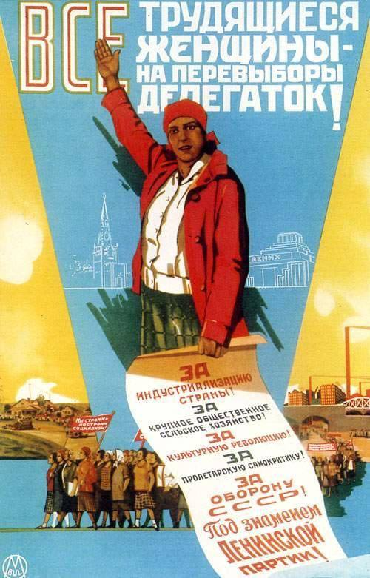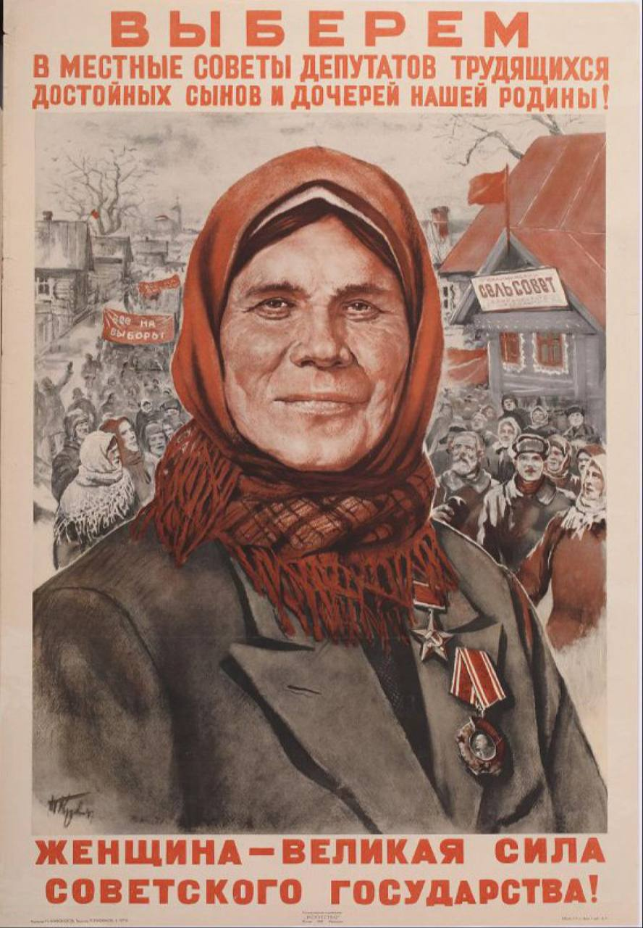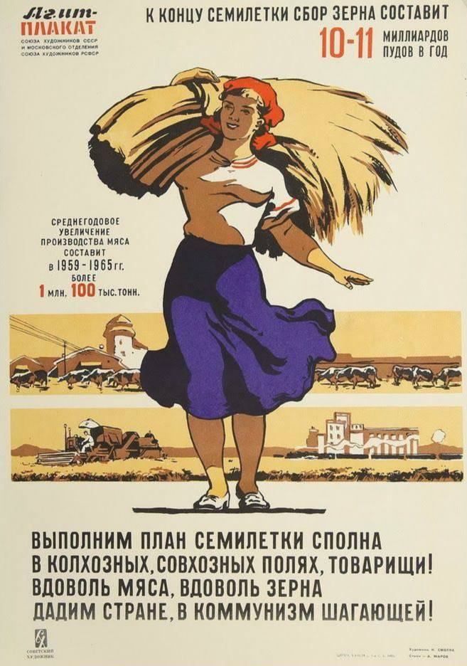
Figure A4 Figure A5 Figure A6
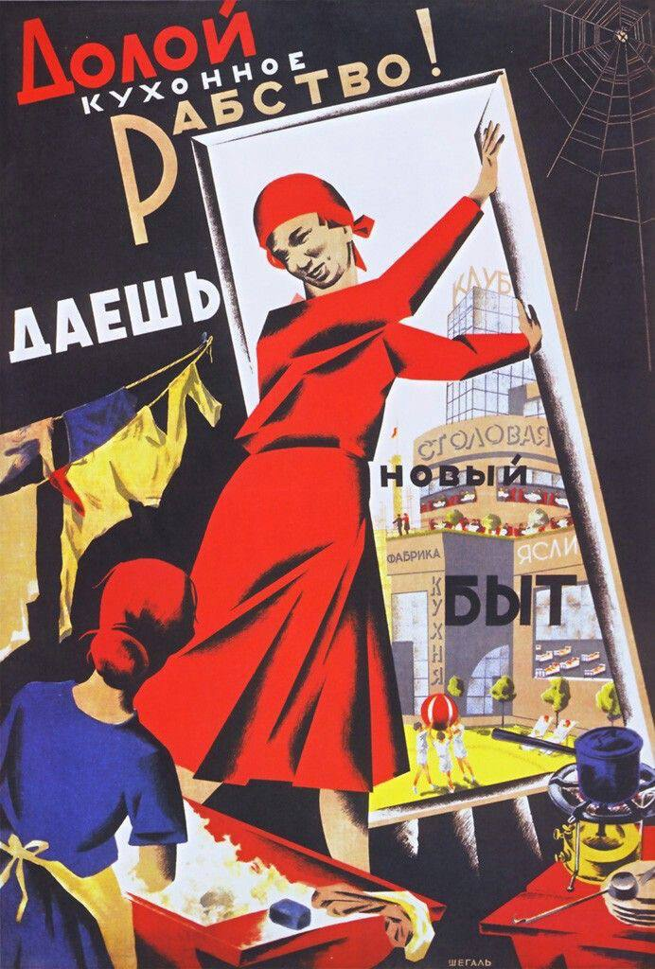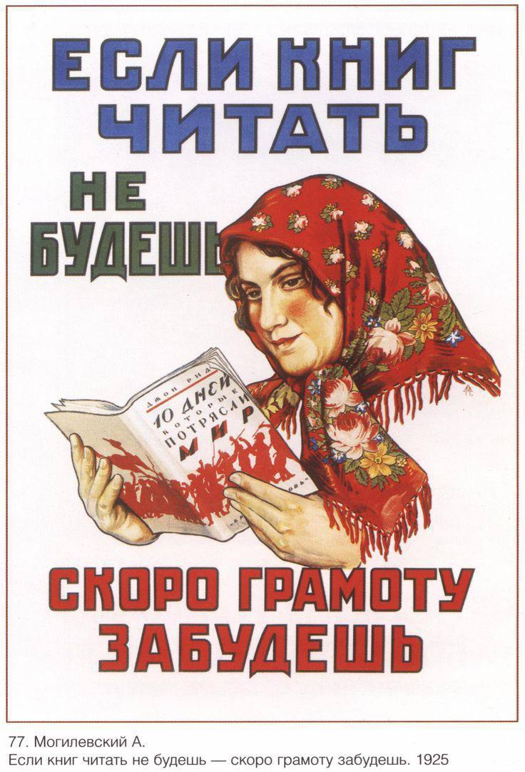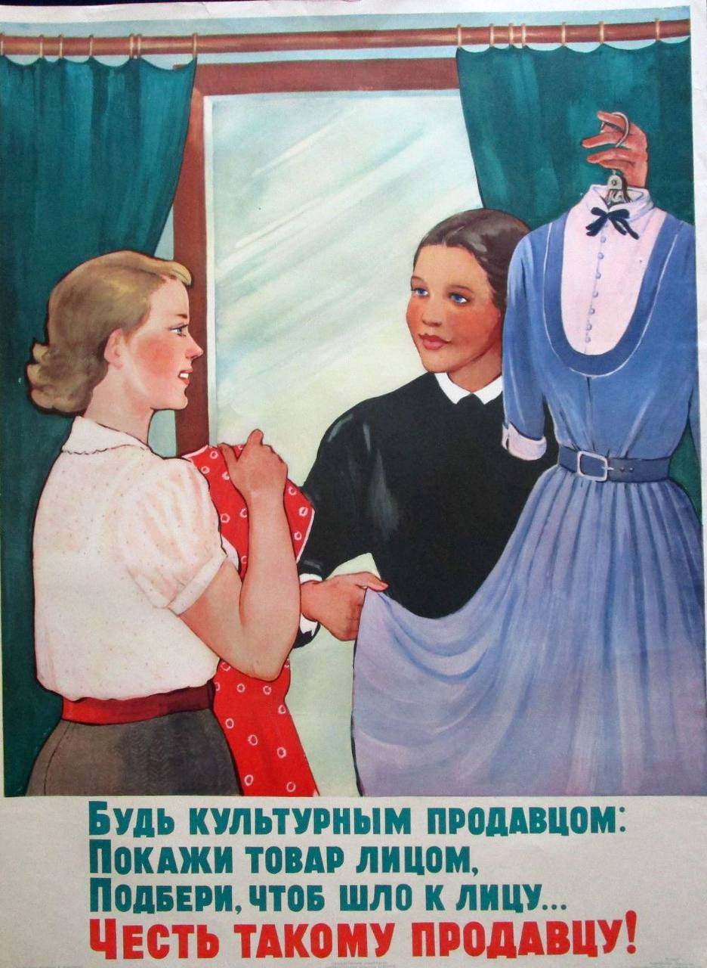

Figure B
The Soviet commercial posters of goods of the 1930s
Figure B1 Figure B2
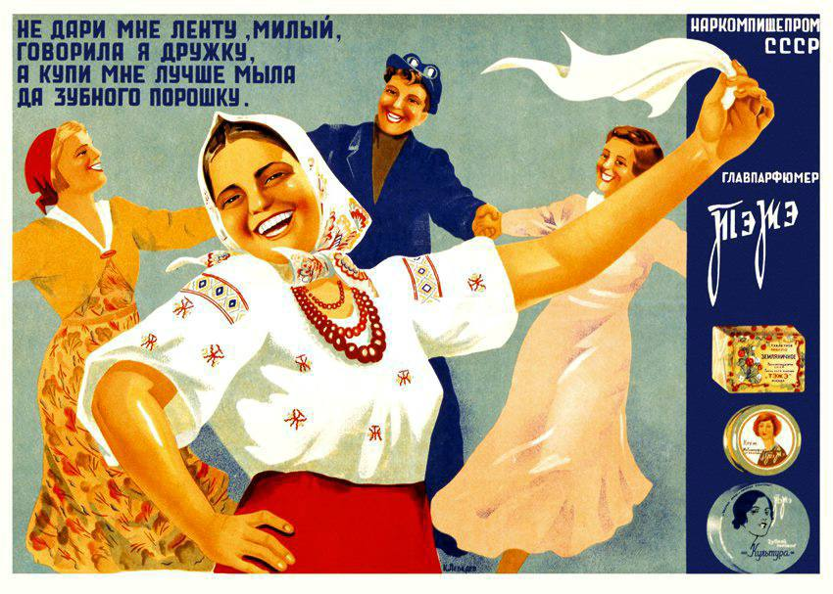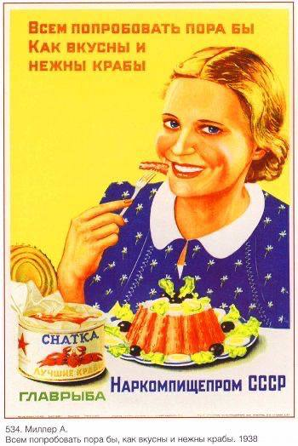
Figure B3 Figure B4
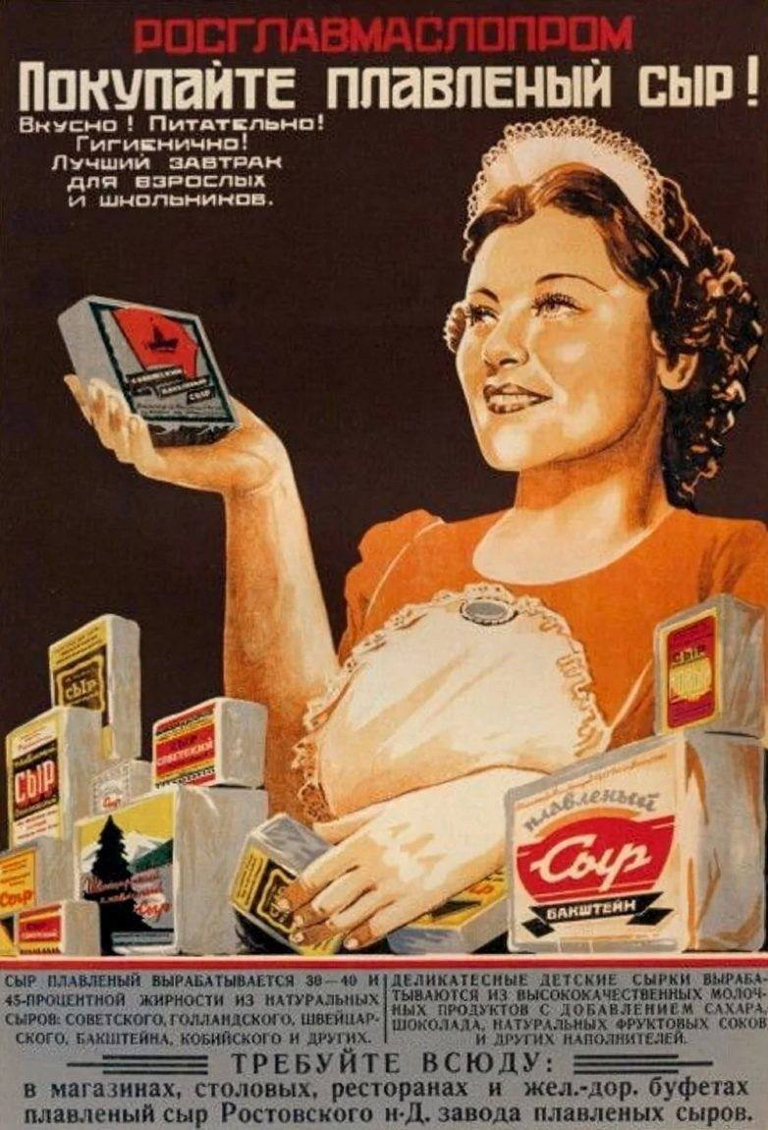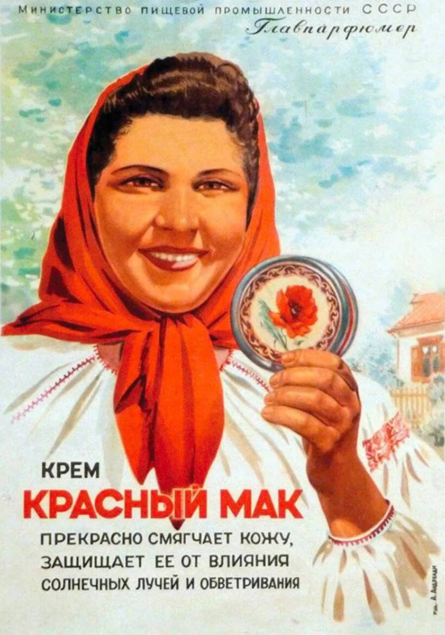

Figure C
The Spanish agitational posters of the 1930s
Figure C1 Figure C2 Figure C3
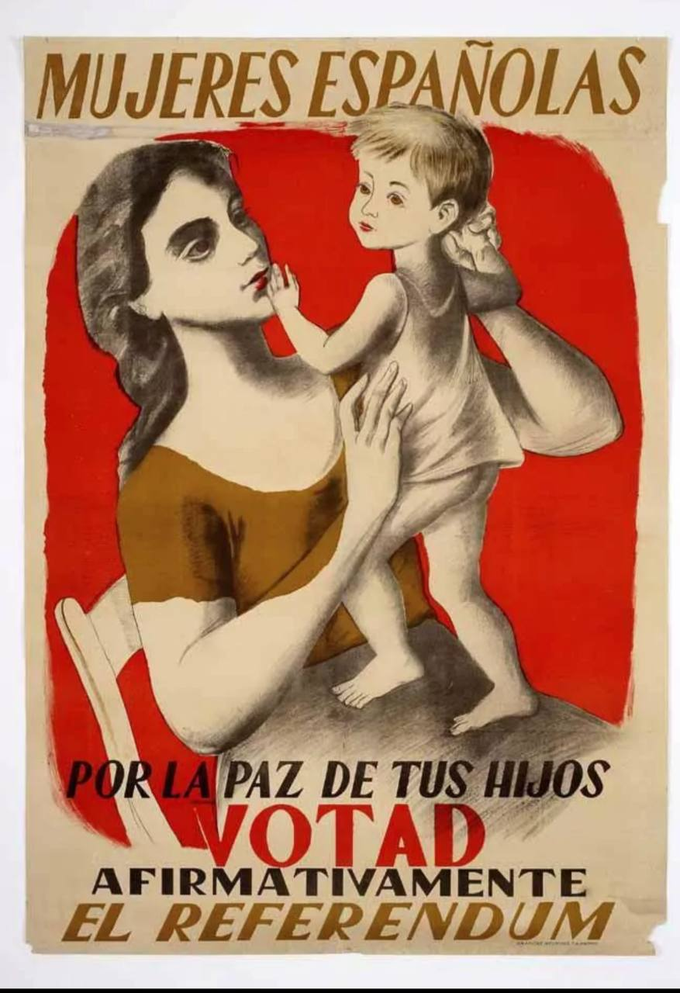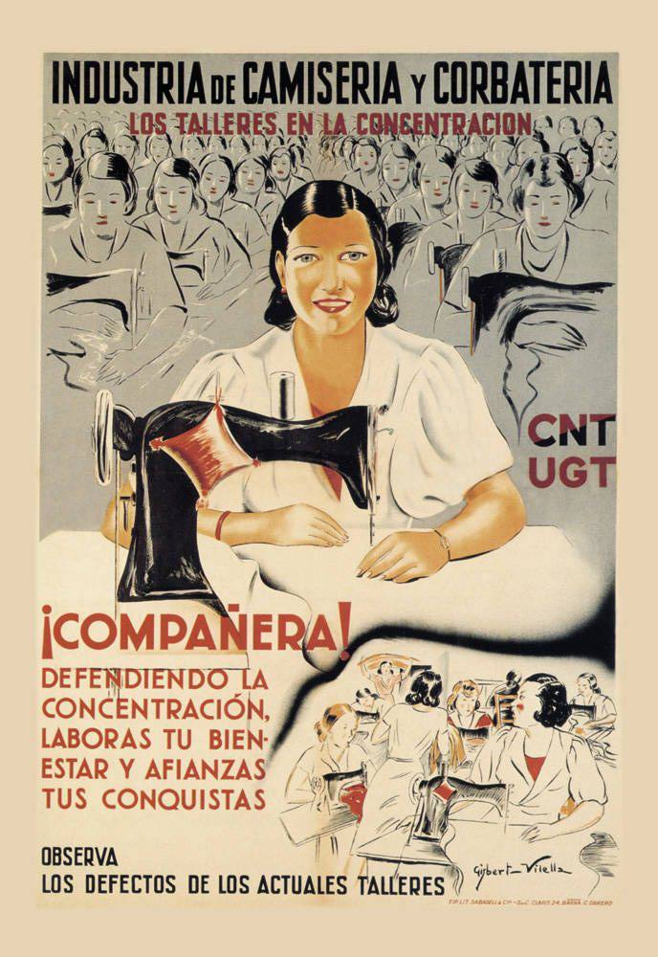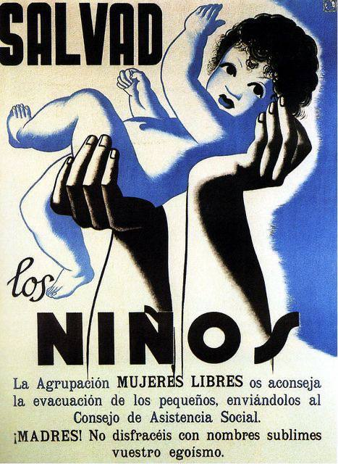
Figure C4 Figure C5
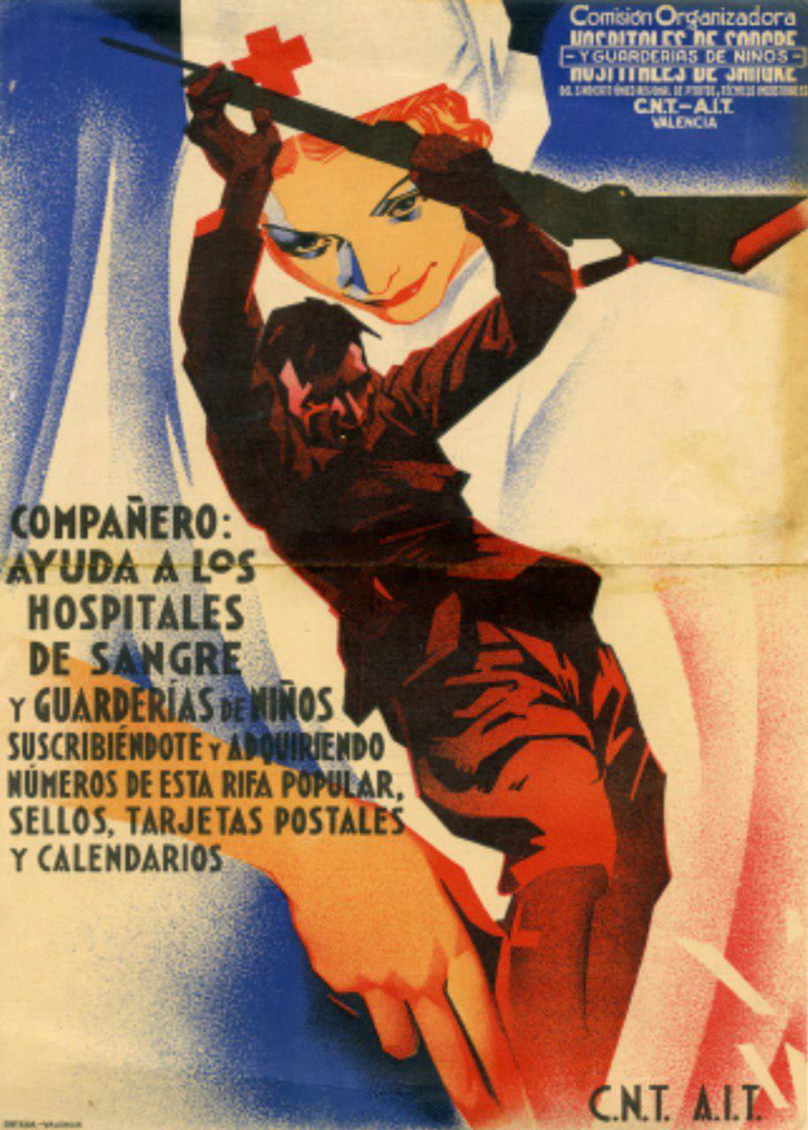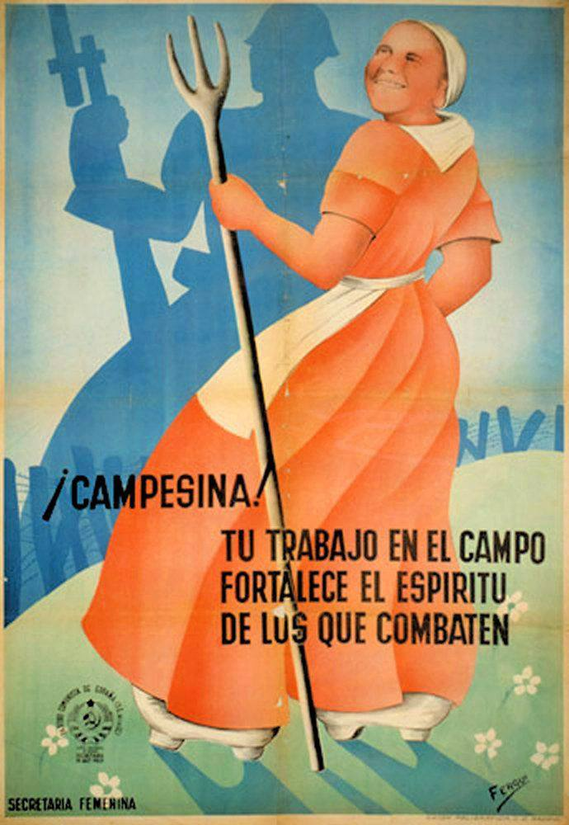

Figure D
The Spanish commercial posters of goods with women of the 2020s
Figure D1 Figure D2 Figure D3
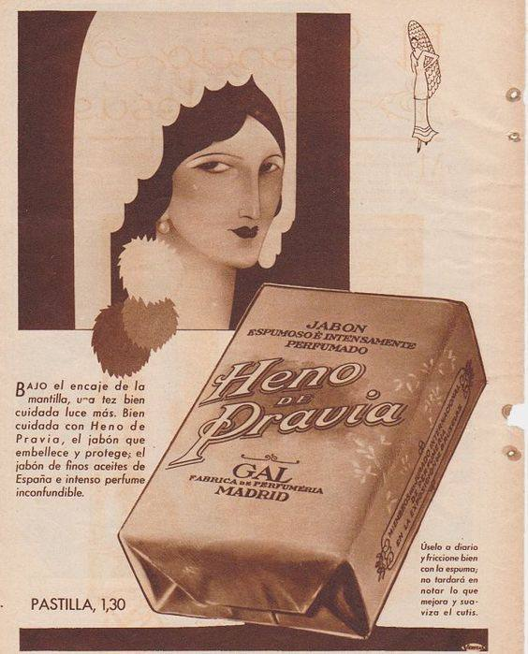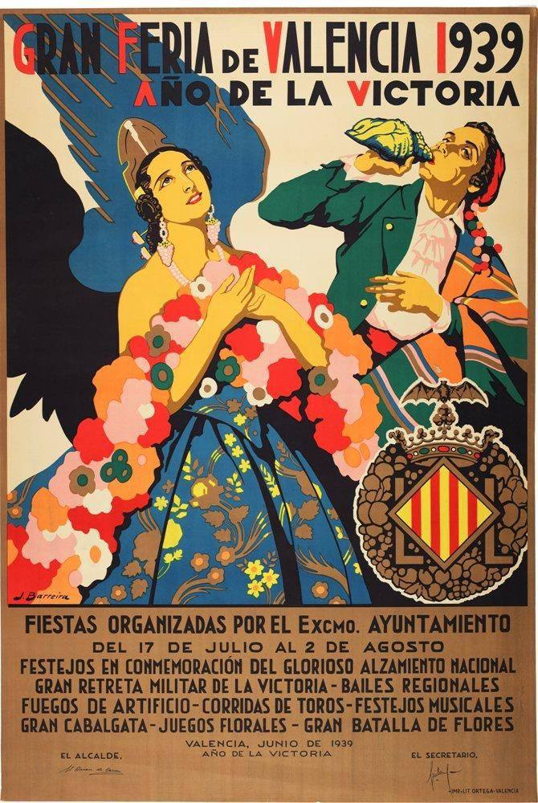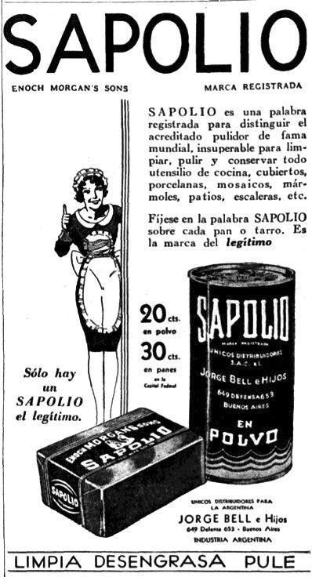
Figure D4 Figure D5
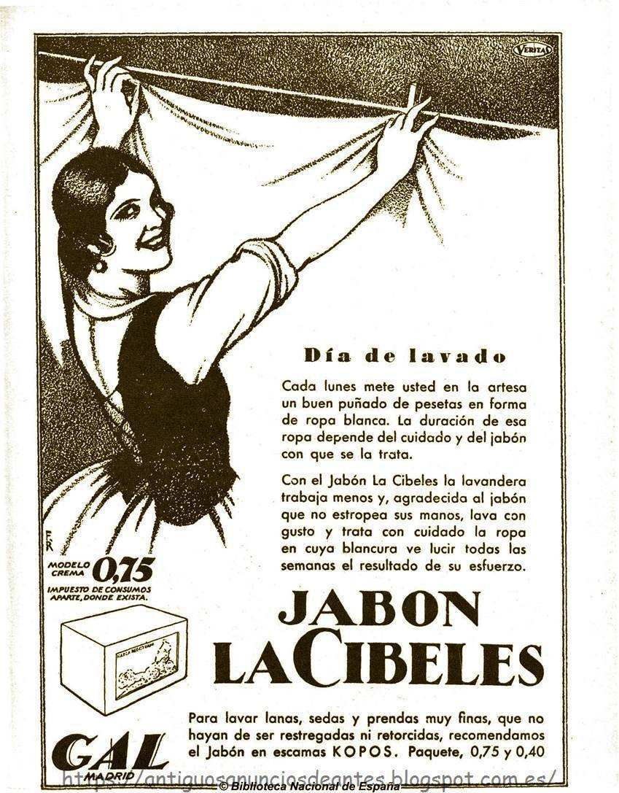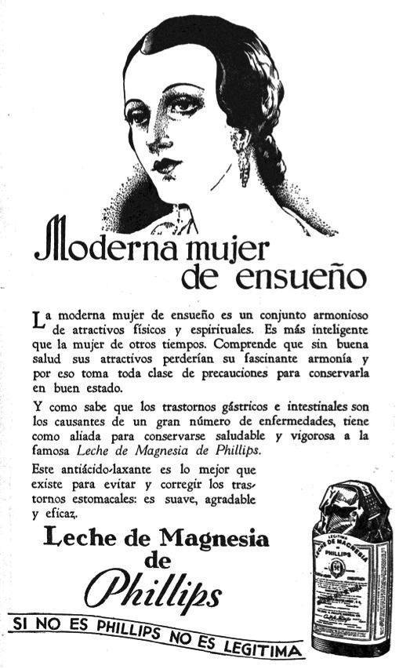

Figure E
The Russian social and motivational ads of the 2020s
Figure E1

Figure E2
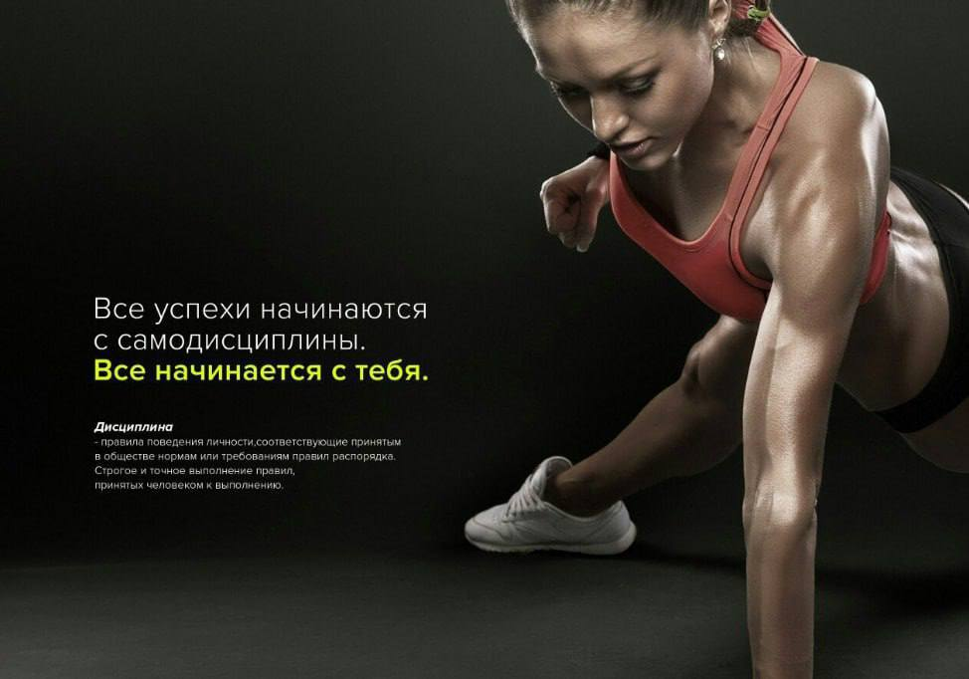
Figure E3
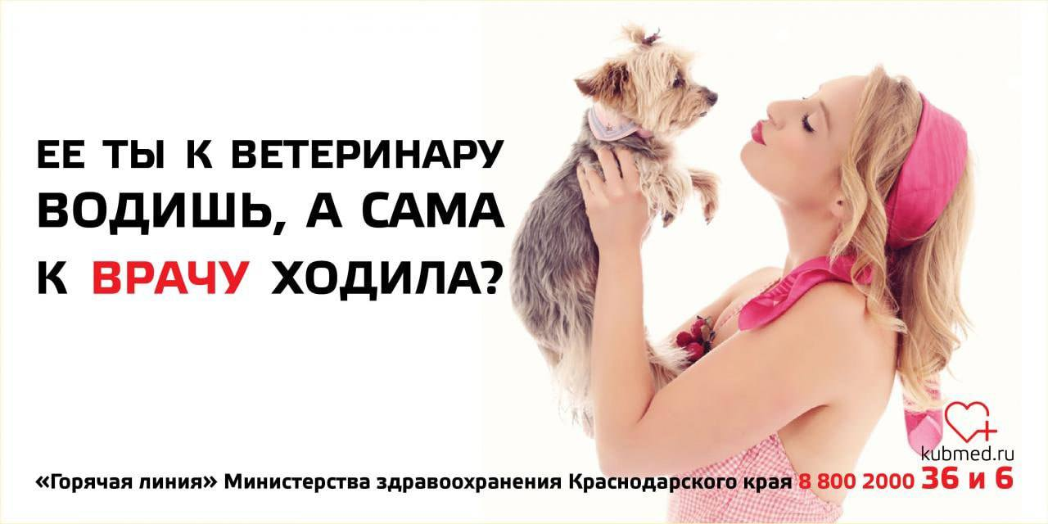
Figure E4

Figure F
Russian commercial ads of goods of the 2020s
Figure F1 Figure F2 Figure F3
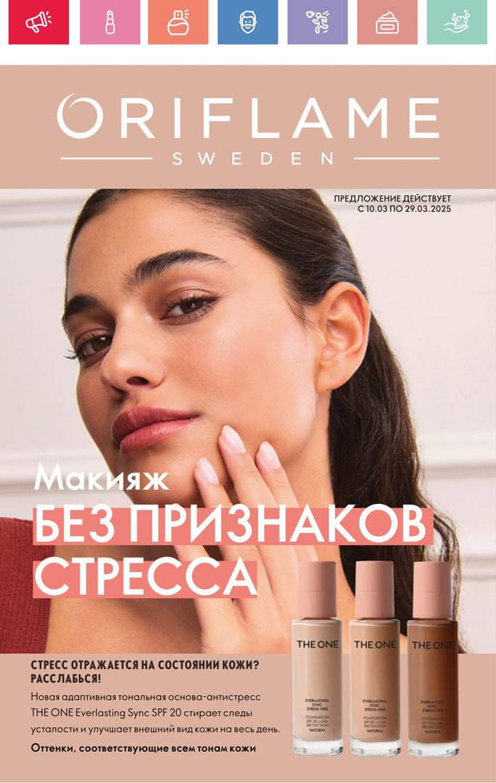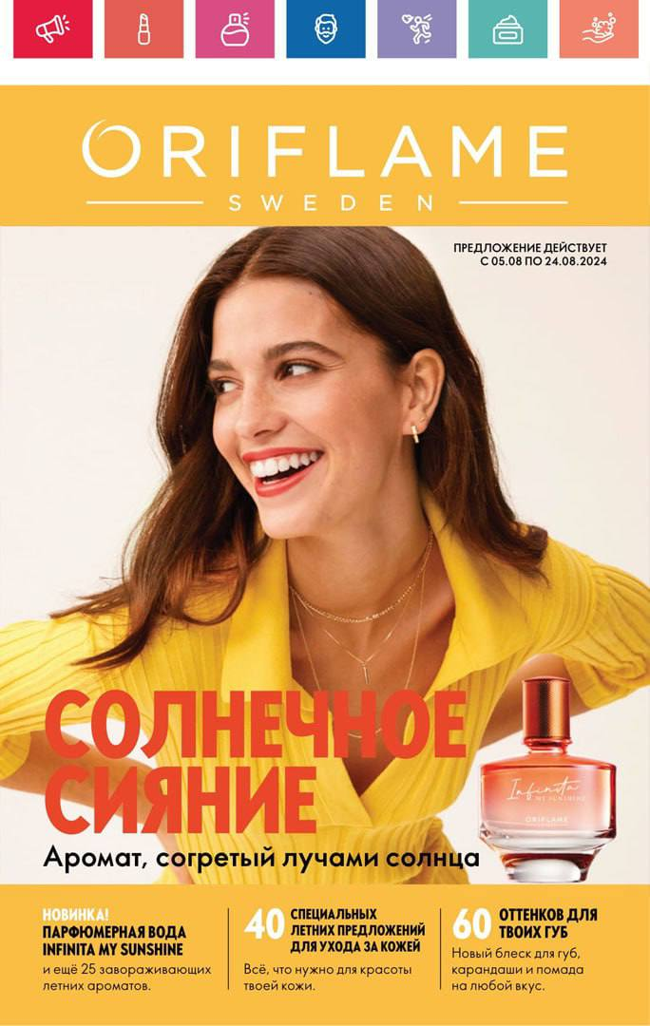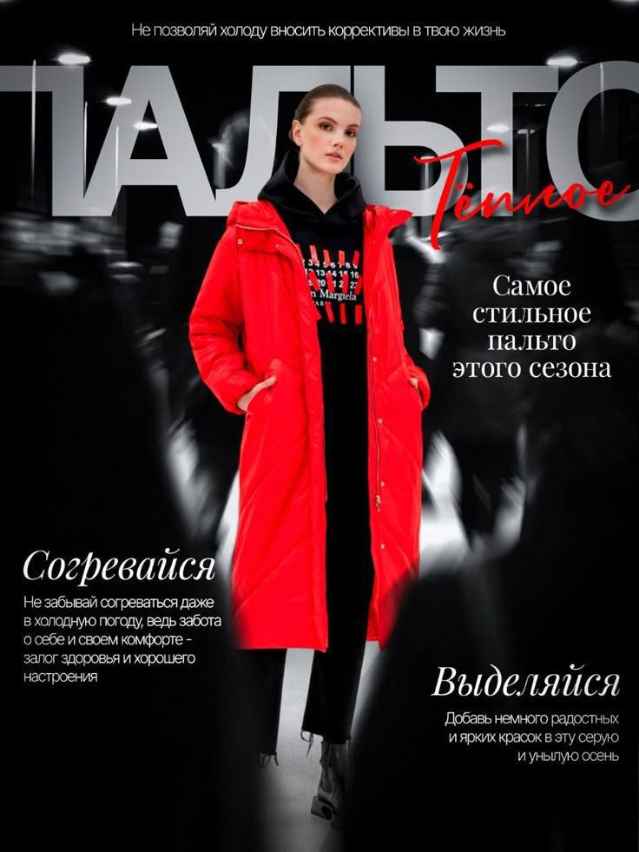
Figure F4 Figure F5
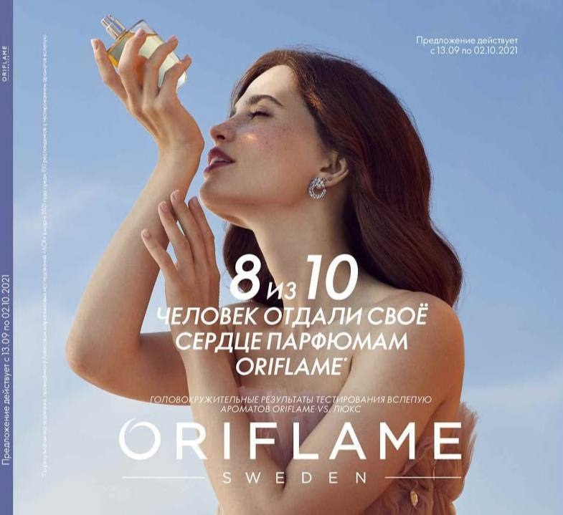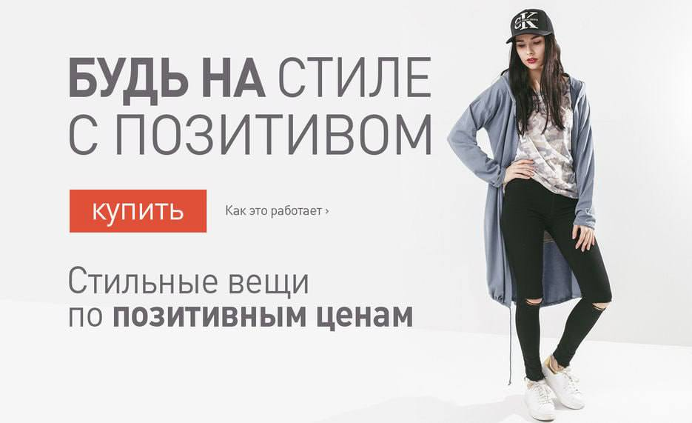
Figure F6
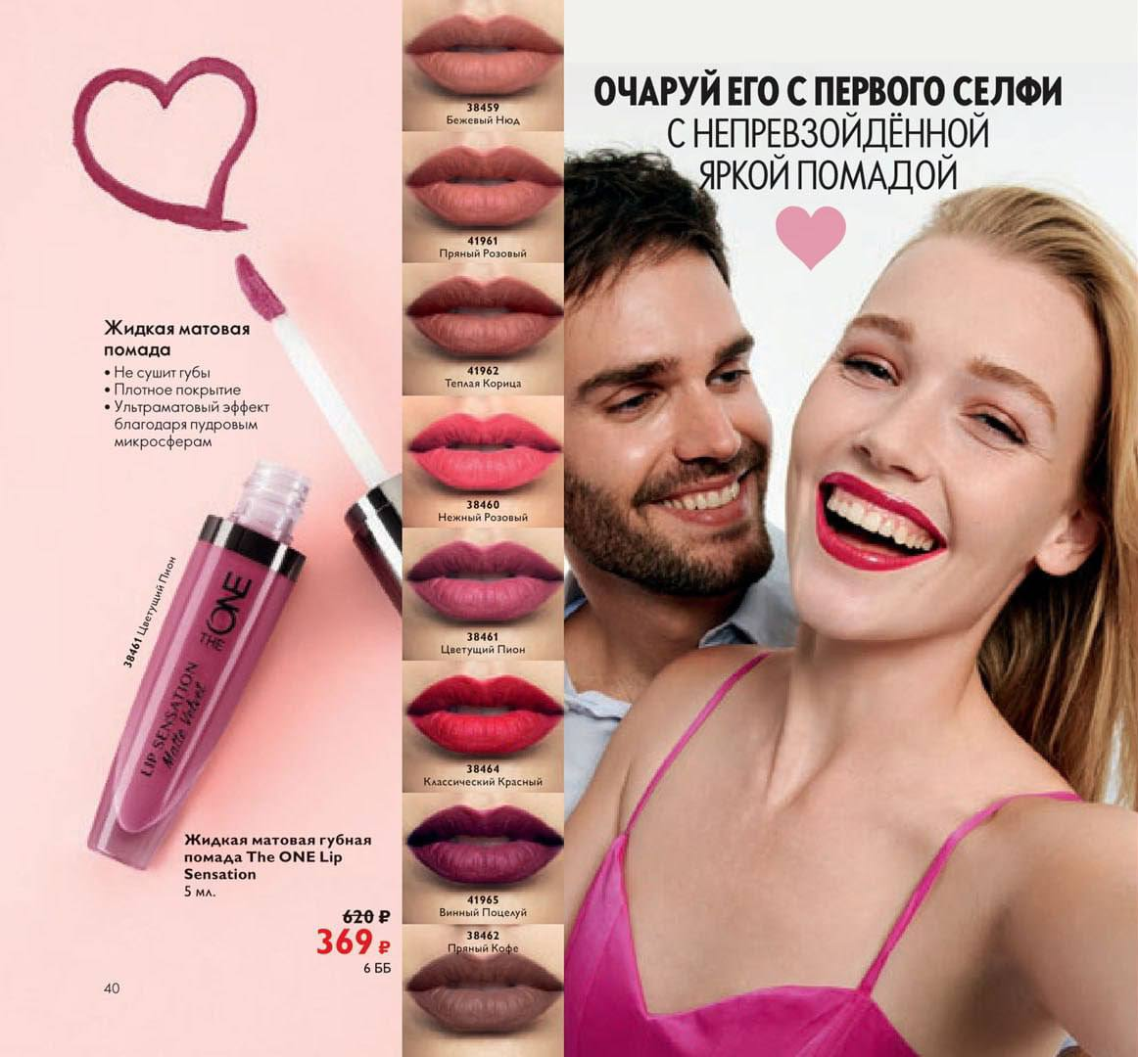
Figure G
Spanish social and motivational ads of the 2020s
Figure G1 Figure G2 Figure G3
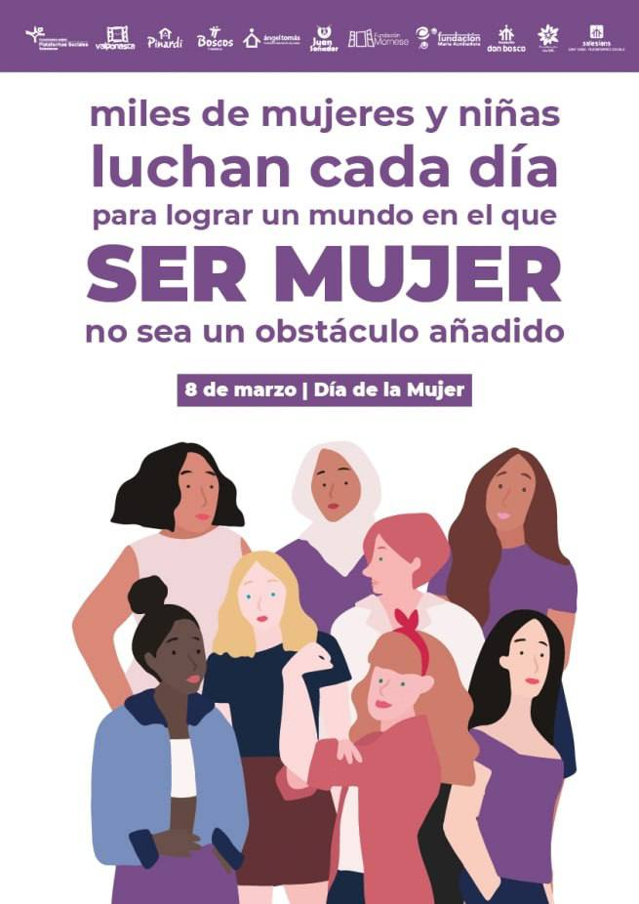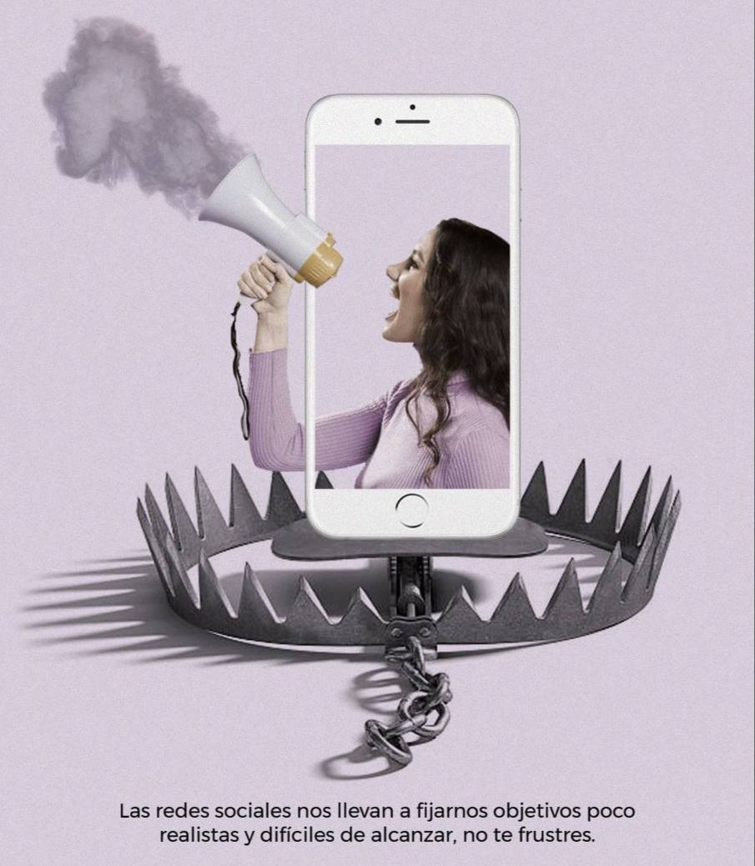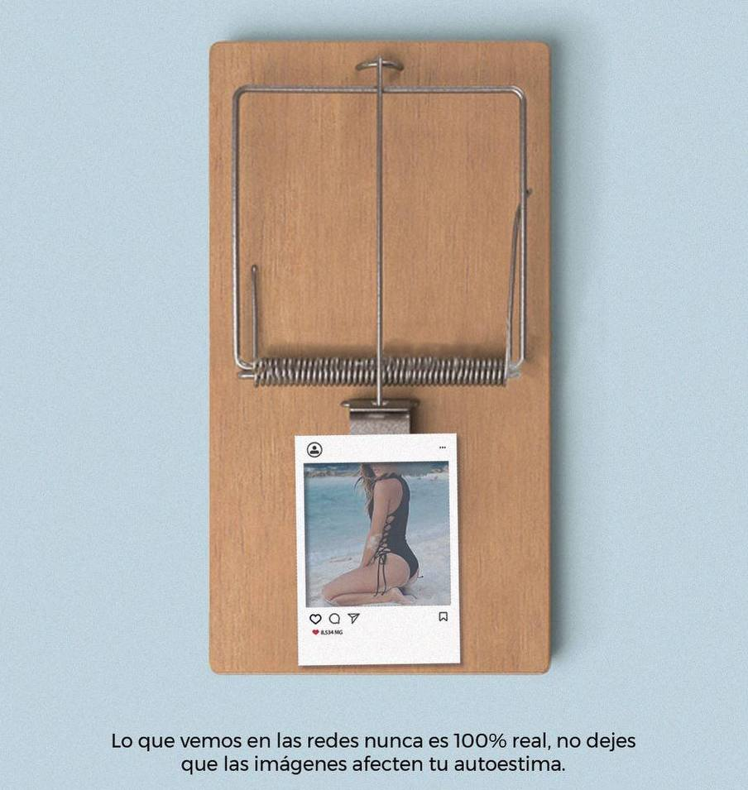

Figure G4


Figure H
Spanish commercial ads of goods of the 2020s
Figure H1 Figure H2 Figure H3
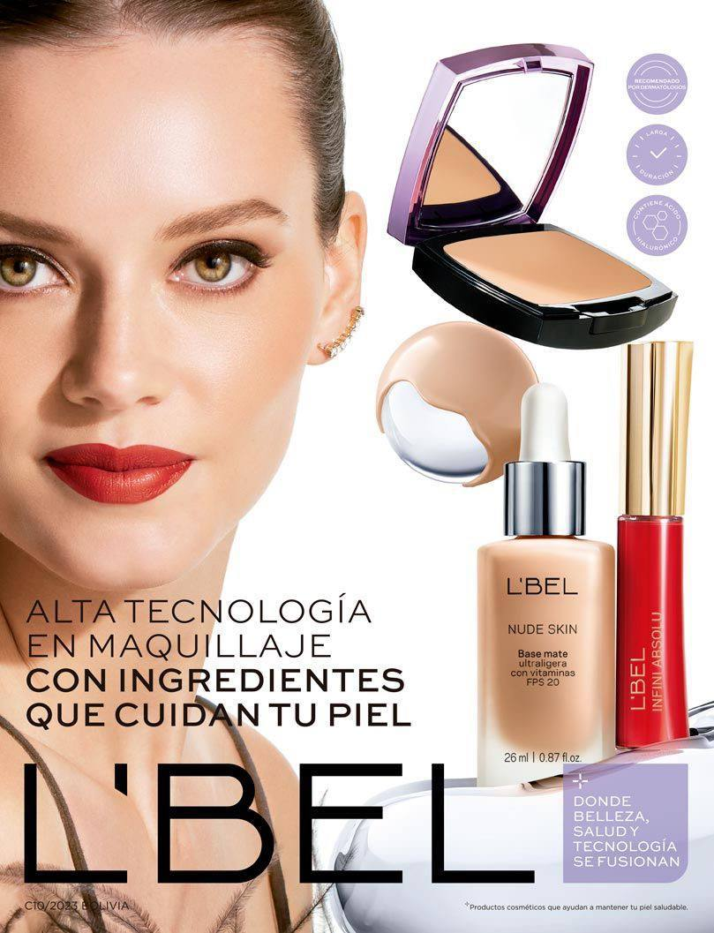

Figure H4 Figure H5
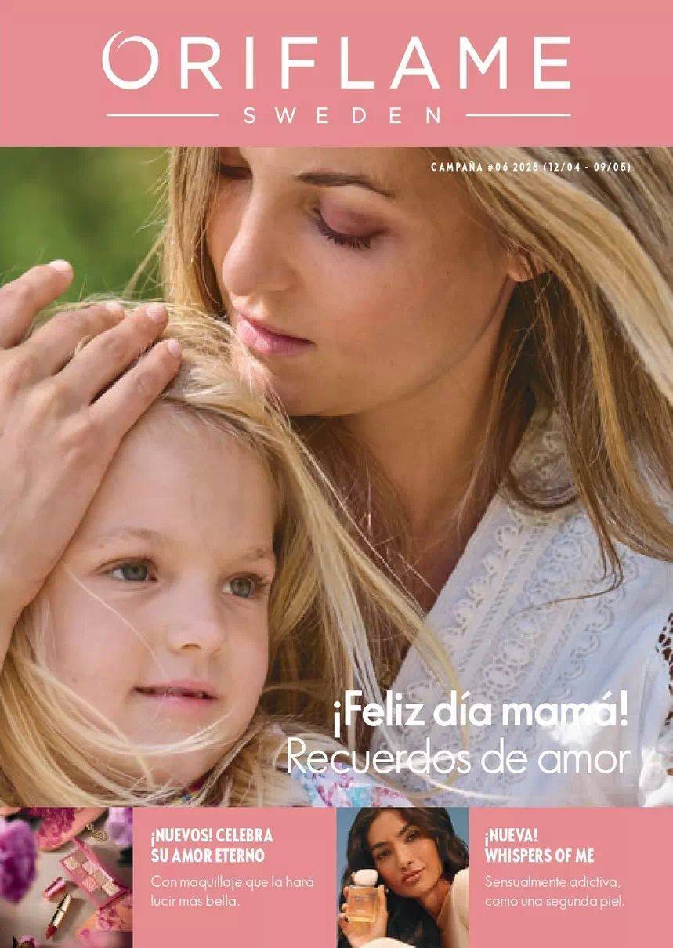
Figure H6
